APPENDIX A



East Sussex
Fire & Rescue Service

Benchmarking Report

2021/22

APRIL 2023

Background

This document aims to provide benchmarking information for East Sussex Fire & Rescue Service (ESFRS) against its other Family Group 2 (FG2) members. The UK’s Fire and Rescue Services (FRS) are divided into five family groups, these groups are used to aid analysis and comparisons between similar FRS. ESFRS is grouped together with other similar sized FRS, which are deemed to have some, but by no means all of the same key characteristics.

The twelve FRS that make up FG2 are:
Bedfordshire
Royal Berkshire
Buckinghamshire
Cambridgeshire
Dorset & Wiltshire
Durham
East Sussex
Norfolk
Northamptonshire
Oxfordshire
Suffolk
West Sussex.

Previously FG2 reported on thirteen members, but this has now reduced to twelve since Dorset & Wiltshire have now combined as one service and their statistics are now reported as one.

This benchmarking report focuses on the following areas:

- Employee comparisons from the ‘Fire and rescue workforce and pensions statistics: England, April 2021 to March 2022’
- Station and appliance comparisons from the ‘CIPFA annual statistics for 2021-22’
- Health and Safety comparisons from the ‘Fire and rescue workforce and pensions statistics: England, April 2021 to March 2022’
- Incident comparisons from the ‘Fire and rescue incident statistics: England, year ending March 2022’ and the ‘Detailed analysis of response times to fires attended by fire and rescue services: England, April 2021 to March 2022’
- Sickness comparisons for the FG2 from the ‘National Fire & Rescue Service Occupational Health Performance Report April 2021 – March 2022’
- Prevention and protection comparisons from ‘Fire prevention & protection statistics, England, April 2021 to March 2022 – second edition’

On the 1 April 2016 the Home Office took over responsibility for the FRS. ESFRS previously submitted a number of datasets throughout the year to the then Department of Local Government and Communities (day crewedLG). These submissions are now being returned to the Home Office.

The most current Home Office datasets were released in October 2022. The figures in this report are based on the latest published figures and regional demographic information. The Appliance and Station numbers are based on data released by CIPFA (annual statistics for 2021-22) and the Employee and Health & Safety comparisons are based on 2021-22 Operational Statistics data collection returns. These returns reflect the positions within each organisation as of 31 March 2022. Sickness data is provided directly from Fire and Rescue Services in the ‘National Fire and Rescue Service Occupational Health Performance Report April 2021 – March 2022’. This report is prepared by Cleveland Fire and Rescue Service.

The Home Office collate the Annual Operational Statistics data collection returns and produce Fire and Rescue Service Operational Statistics Bulletins (Fire prevention and protection statistics: England, April 2021 to March 2022). These contain data from each UK FRS on:

- Fire Prevention and Community Fire Safety Activities
- Fire Safety Audits, Enforcement, Prohibition and Compliance Notices, and Prosecutions

The Home Office collate the Annual Operational Statistics data collection returns and produce Fire and Rescue Service Operational Statistics Bulletins (Fire and rescue workforce and pensions statistics: England, April 2021 to March 2022). These contain data from each UK FRS on:

- Staff strength by rank and contract
- Health and Safety – Injuries during operational incidents and training
- Vehicle Incidents and Accidents

All the Operational Statistics datasets are in the public domain and can be accessed via the GOV.UK website or using this link https://www.gov.uk/government/collections/fire-statistics

The Home Office also collect and collate the E-IRS data sets and produce the ‘Detailed analysis of fires attended by fire and rescue services, England, April 2021 to March 2022’ and the ‘Response times to fires attended by fire and rescue services: England, April 2021 to March 2022’.

These contain data from each UK FRS on:

- Incident types
- Attendance times
- Fatalities and casualties

All Fire Statistics and Incident Response Times datasets are in the public domain and can be accessed via the GOV.UK website by using these links: https://www.gov.uk/government/statistical-data-sets/fire-statistics-data-tables

Population and Geographic details

To create meaningful comparators across the Family Group 2 (FG2) the performance indicators are often expressed as a rate or ratio against a standard demographic or geographic value.

Table 1 sets out these main comparators. It shows, with regard to population, East Sussex Fire & Rescue Service (ESFRS) is most comparable to Northamptonshire and Buckinghamshire; and with domestic properties (occupied dwellings) and non-domestic properties, Cambridgeshire and Suffolk respectively. ESFRS has the 7th highest population (823,100), the 6th highest number of occupied dwellings (361,500) and the 3rd highest number of non-domestic properties (33,030) but it is the 3rd smallest in area among FG2.

ESFRS, with regard to full-time equivalents (FTE), has the 3rd highest number of Wholetime and 4th highest number of On-call firefighters. This is the 3rd highest number of wholetime and On-call combined.

Table 1: Sources: (i & ii) CENSUS 2021 (iii) GOV UK - Non-Domestic Rating Stock of Properties 2022 (iv, v & vi) Home Office Operational Statistics - Fire 1101 (vii) CIPFA Fire and Rescue Service Statistics 2022.

Locations of the Family Group 2 Fire and Rescue Services
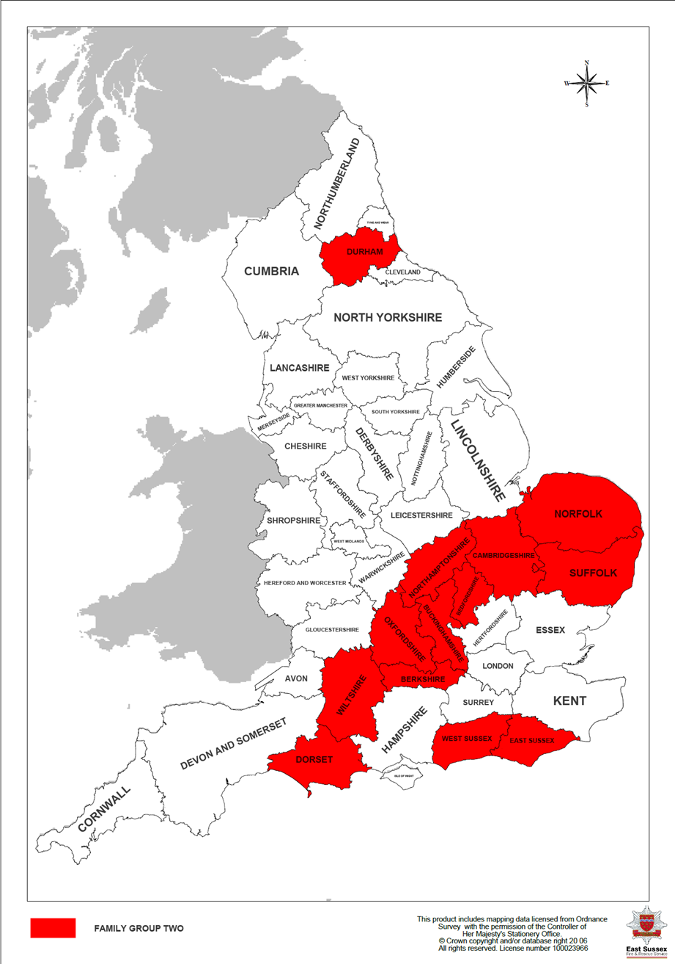

Employee comparisons

Table 2 shows that the ESFRS’s senior management structure is comparable to Bedfordshire and Oxfordshire. Overall, ESFRS has the 3rd highest numbers of wholetime operational staff in FG2.

Additionally, the figures represent the ‘Strength’ of each FRS. This is the actual number of wholetime operational posts filled as per contract as of 31st March 2022. They do not include any temporary posts or posts that are fully funded by outside agencies; for example, persons seconded to the Ministry for Housing, Communities and Local Government (MHCLG), the Home Office, HMICFRS, Fire Service College or charitable organisations. Posts such as these are not included in the FRS’s ‘Strength’ figures. However, the figures reflect temporary promotions within the organisation.

ESFRS has the 3rd highest percentage change in wholetime operational staff against the numbers stated in the 2020/21 Benchmarking Report. The 4.8% increase equates to 17 wholetime posts but this is a decline of 59 wholetime posts since 2011. The average ratio of firefighters to Senior Managers in FG2 is 20 to 1, so with 28 to 1, ESFRS is significantly above this and has the equal highest ratio.

*Senior Manager includes Brigade Manager, Area Manager & Group Manager.
Table 2: Source - Home Office Incident Recording System, Fire statistics table 1102a: Total Staff Numbers (FTE) by role and fire and rescue authority – Wholetime Firefighters.

Table 3 shows the FG2 management structure at station level. ESFRS has the 2nd highest number of Watch and Crew Managers; equal 2nd highest wholetime and Day crewed stations; and the 5th lowest average number of watch and crew managers by day crewed and wholetime station with 10.17. The FG2 average is 10.64.

Table 3: Source - Home Office Incident Recording System, Fire statistics table 1102a: Total Staff Numbers (FTE) by role and fire and rescue authority – Wholetime Firefighters. Number of Stations: CIPFA Fire and Rescue Service Statistics 2021-22 Actuals.
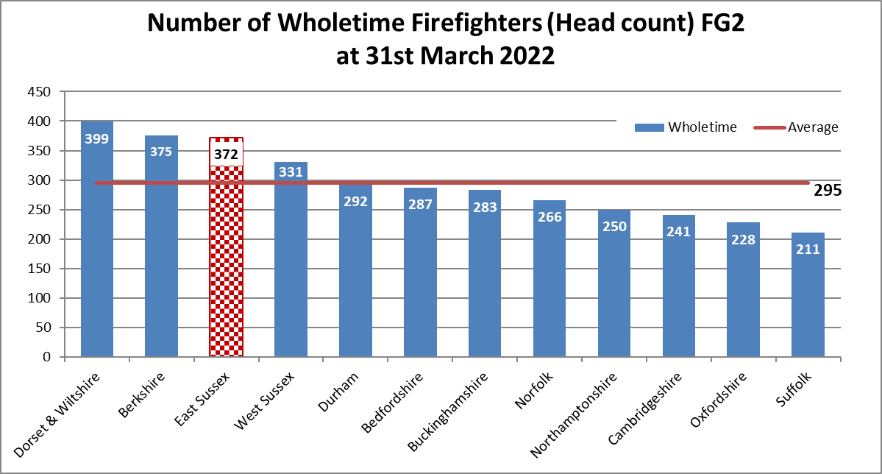
Chart 1, below, shows the comparisons of wholetime firefighters (head count) across FG2. ESFRS is above the FG2 average of 295, with 372.

Chart 1: Number of wholetime Firefighters. (Source - Home Office Incident Recording System, Fire statistics table 1101: Staff in post employed by FRA by head count – Wholetime Firefighters.)

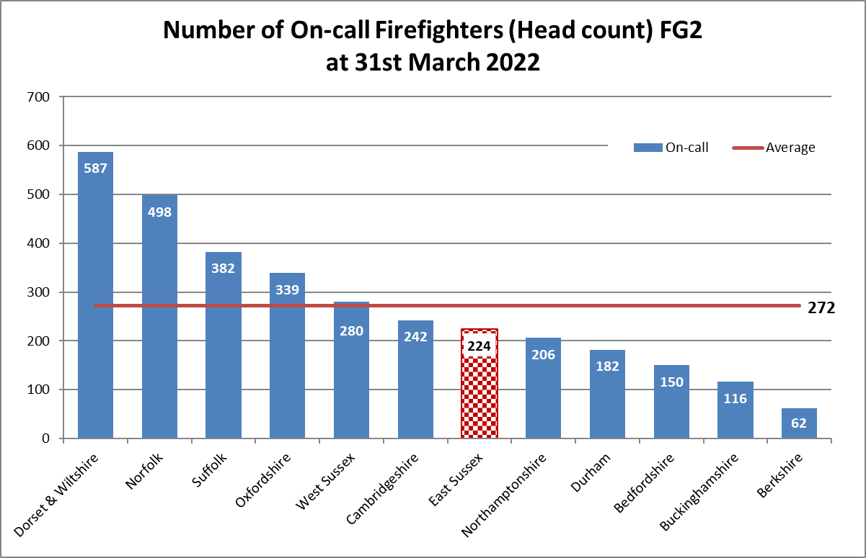
Chart 2 shows the comparisons of On-call firefighters (head count) across FG2. The average number of On-call firefighters across the group is 272, whereas for ESFRS this is 224. The On-call staffing model is often dependent on several factors, including geographical location, the number of incidents in an area and the levels of risk within an area.

Chart 2: Number of On-call Firefighters. (Source - Home Office Incident Recording System, Fire statistics table 1101: Staff in post employed by FRA by head count – On-call Firefighters.)
Stations and Appliances comparisons
Table 4 shows number of pumping appliances across area and population. ESFRS has the 5th highest number of pumping appliances among FG2 with 41. This is above the group average of 37.2. ESFRS’s population is concentrated mostly on the coast by comparison to many other FG2 members and therefore impacts on the area per pumping appliance.
Table 4: Number of pumping appliances. (Source - CIPFA Statistics 2021/22 Actuals.)

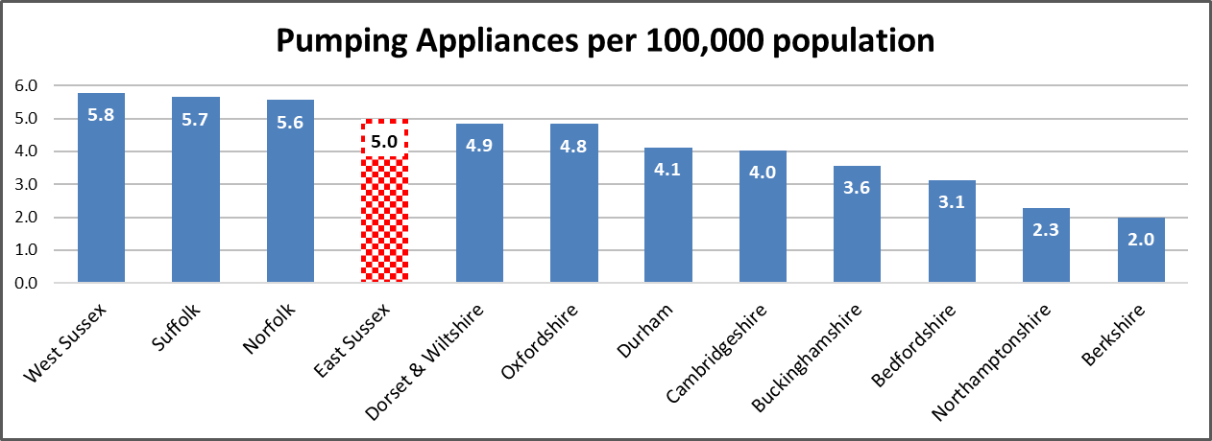
Chart 3 presents the number of pumping appliances per 100,000 population. ESFRS has the 4th highest with 5.0, which is above the FG2 average of 4.2.
Chart 3: Pumping Appliances per 100,000 population. (Source - CIPFA Statistics 2021/22 Actuals.)
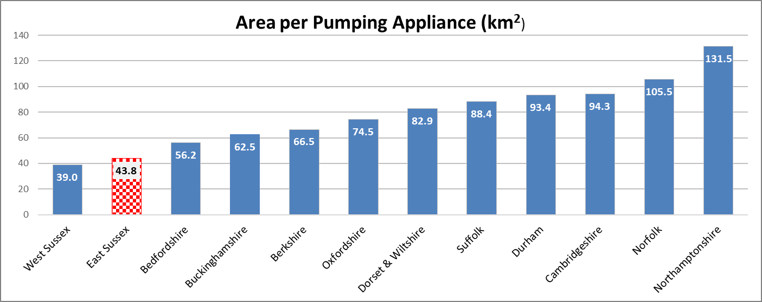
Chart 4 shows area per pumping appliance. ESFRS has the 2nd highest pumping appliance density with one to every 43.8 km². The FG2 average one to every 78.2 km².
Chart 4: Square kilometers per appliance. (Source - CIPFA Statistics 2021/22 Actuals.)

Table 5 shows the number of stations per 100,000 population and area per station in km² for each FG2 FRS. ESFRS has 6 wholetime, 6 day crewed and 12 On-call stations, which is proportionally closest to Buckinghamshire with regard to station type in FG2.
Table 5: Number of Stations. (Source - CIPFA Statistics 2021/22 Actuals)
*Cambridgeshire has 1 Volunteer Fire Station; ** West Sussex also share an additional station with Surrey FRS.

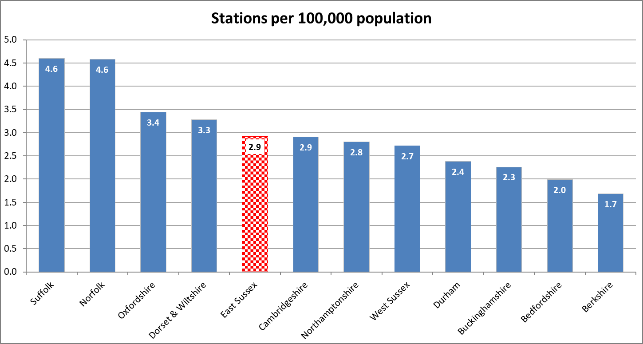
Chart 5 presents number of stations per 100,000 population. ESFRS has a rate of 2.92 stations per 100,000 population, this is the 5th highest in FG2.
Chart 5: Stations per 100,000 population. (Source - CIPFA Statistics 2021/22 Actuals.)

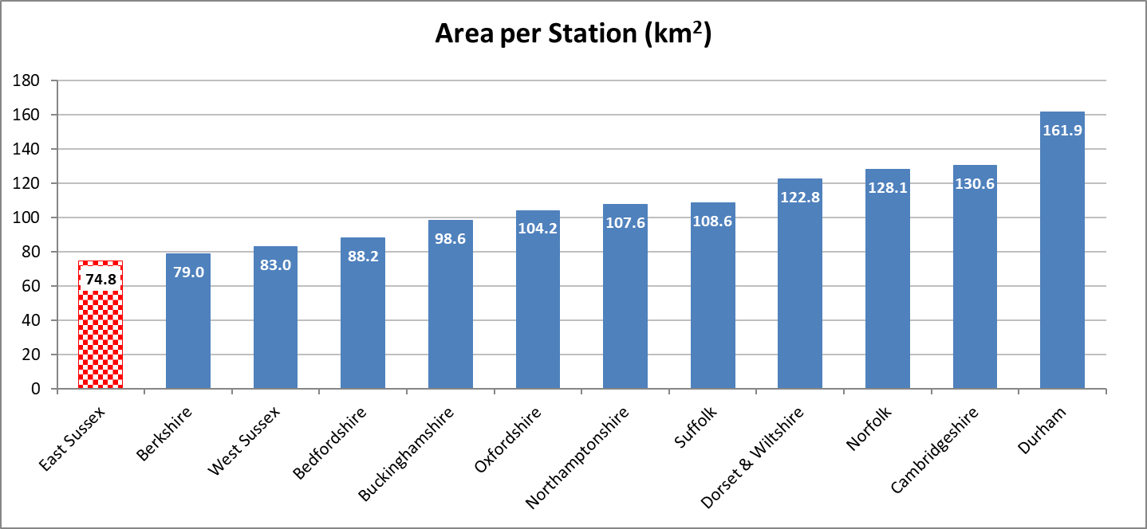
Chart 6 shows area per station in km². ESFRS has one station for every 74.8 km², which is the highest density of stations per km² in FG2.
Chart 6: Stations per square km. (Source - CIPFA Statistics 2021/22 Actuals.)
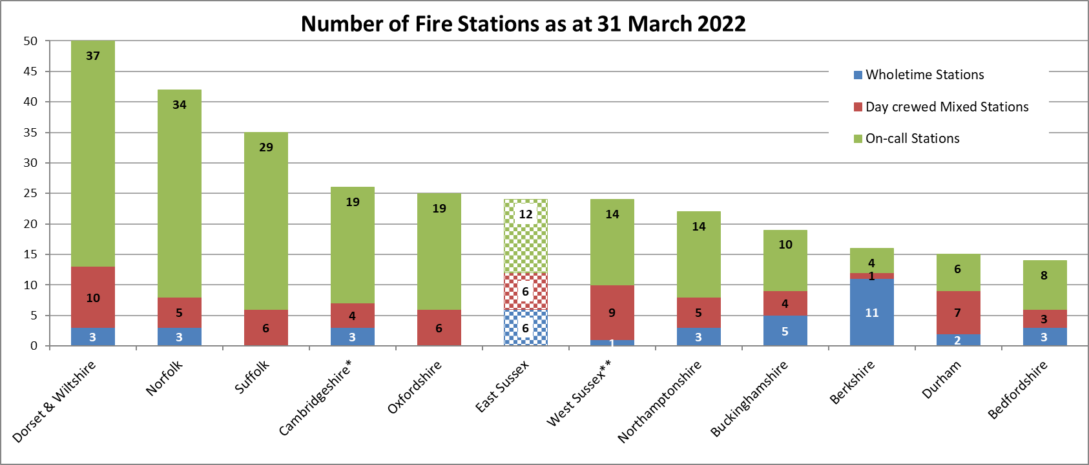
Chart 7 highlights the number of wholetime, day crewed and On-call stations for each FG2 member. Berkshire has the highest number of wholetime stations (11), Dorset and Wiltshire has the highest number of Day and mixed crewed (10), and On-call stations (37). Dorset & Wiltshire (50) and Norfolk (42) have the most stations overall, whilst Bedfordshire (14) and Durham (15) have the least among FG2.
Chart 7: Number of Stations. (Source - CIPFA Statistics 2021/22 Actuals)

Financial comparisons

Chart 8 shows the average net expenditure of each FRS in FG2 per domestic household and average Band D equivalent Council Tax for each FRS and for Combined Fire Authorities. (This information is not readily available for County Fire Authorities, as Fire budgets are generally combined with other departments.)

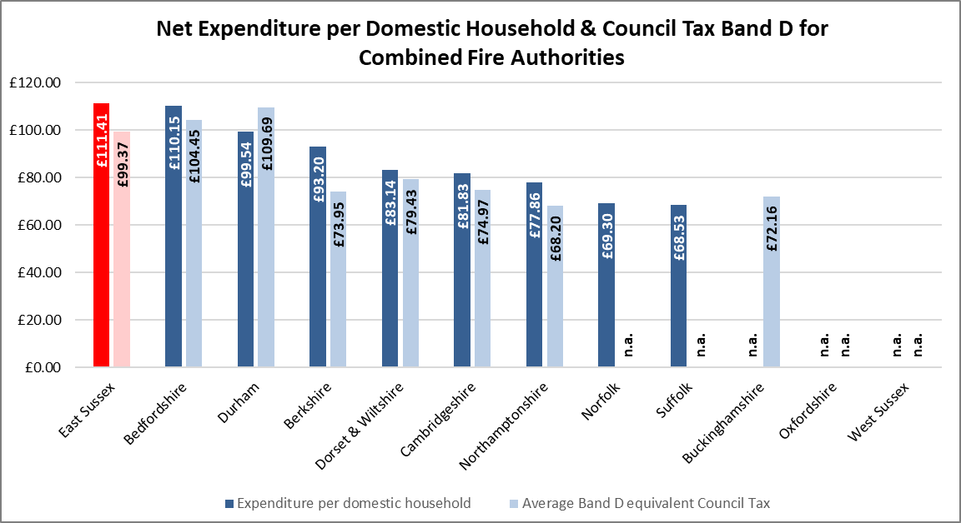
ESFRS has the highest average net expenditure cost per domestic household and the 3rd highest cost per Council Tax Band D.
Chart 8: Average net expenditure per number of domestic properties & Council Tax Band D. (Source - CIPFA Statistics 2021/22)

Health & Safety
Chart 9, below, shows the number of injuries per 100 wholetime and On-call firefighters sustained during operational incidents and training for FG2. In 2021/22, ESFRS sustained 5.03 operational injuries per 100 firefighters (8.25 in 2020/21) and 2.35 training injuries per 100 firefighters (1.52 in 2020/21). The FG2 average number of operational injuries per 100 firefighters is 3.45 and the average rate for training injuries is 3.55 per 100 firefighters.

ESFRS is considerably above the FG2 average in operational injuries, currently ranked 2nd highest (the same as in 2020/21) and below the average in training injuries, ranked 2nd lowest (3rd lowest in 2020/21). Cambridgeshire continues to have the most operational and training injuries, whilst Durham again has the least operational injuries. Suffolk has the least training injuries per 100 firefighters among FG2.
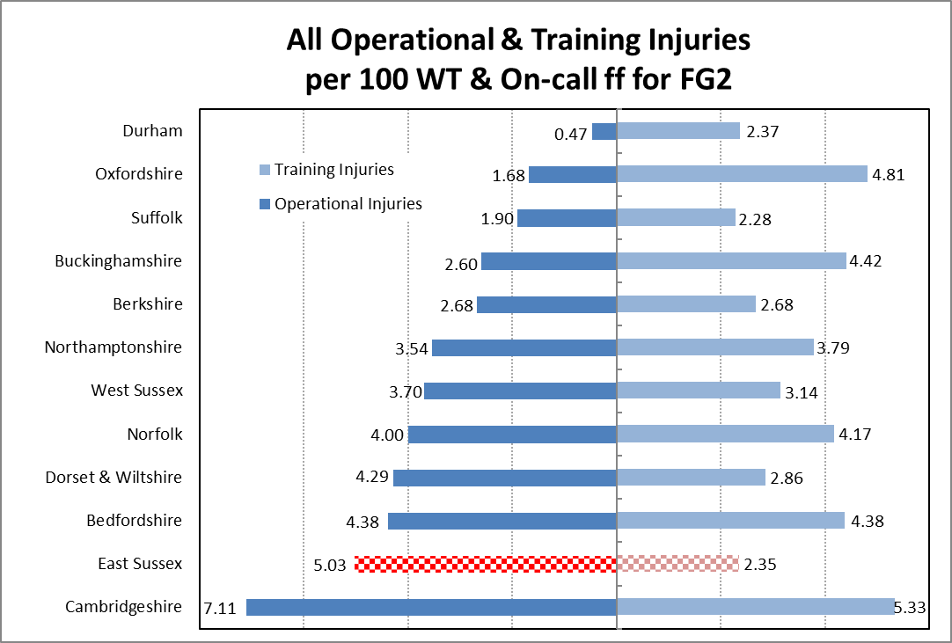
Chart 9: Operational & Training Injuries per 100 firefighters. (Source - Home Office, Fire statistics tables 0508b: Injuries sustained by firefighters and firefighter fatalities, during operational incidents, by fire and rescue authority & 0508c: Injuries sustained by firefighters and firefighter fatalities, during training incidents, by fire and rescue authority.)

Firefighters by Gender and Ethnicity comparisons

Chart 10 shows the percentage of female wholetime firefighters for each FG2 member over the past four years. The profile of wholetime firefighters in England is predominantly male and white. However, the proportion of firefighters who are female has increased from a national average of 1.3% in March 2002 to 8.7% in March 2022. Notably, a significant part of this proportional increase during this period is owing to the large decline in male firefighters (down from 31,168 to 20,712), rather than an actual increase in the numbers of female firefighters (up from 424 to 1,980).

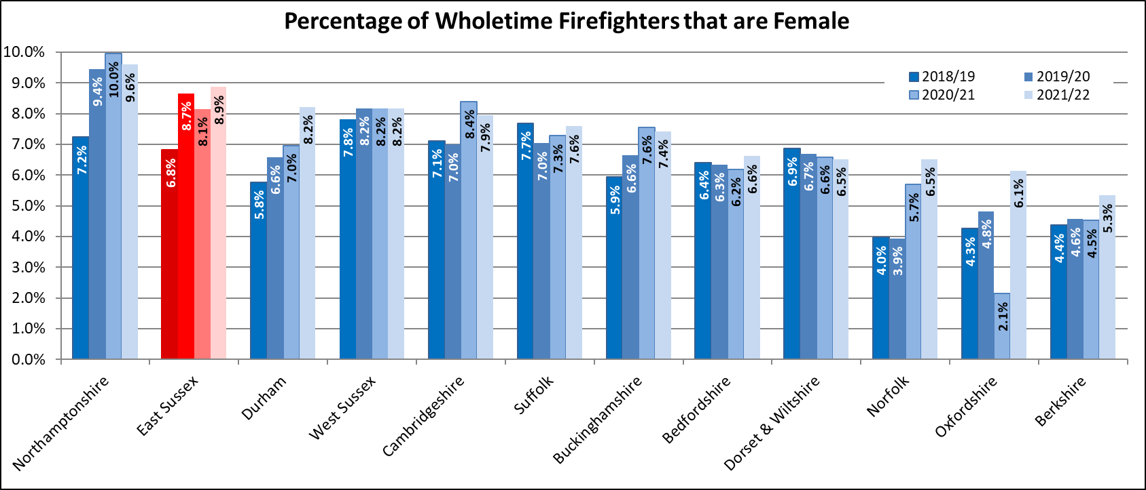
ESFRS has the 2nd highest proportion of female firefighters across FG2 with 8.9% of wholetime firefighters, which is above both the national average of 8.7% and the FG2 average of 7.4%.
Chart 10: Percentage of wholetime firefighters that are female. (Source - Home Office Incident Recording System, Fire statistics table 1103: Staff headcount by gender, fire and rescue authority and role.)

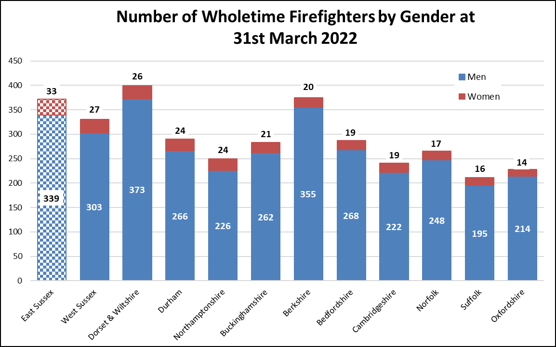
Chart 11 shows the actual numbers of male and female firefighters at each FG2 FRS. In terms of raw numbers, ESFRS has the highest numbers of female firefighters with 33. The lowest number of female fighters was 14 in Oxfordshire FRS.
Chart 11: Numbers of wholetime firefighters that are female. (Source - Home Office Incident Recording System, Fire statistics table 1103: Staff headcount by gender, fire and rescue authority and role.)

Nationally, the percentage of wholetime firefighters from ethnic minority backgrounds has also increased: from an average across all FRSs of 1.5% in 2002 to 6.5% in March 2022. ESFRS is currently below the national average with 4.0%. Only Bedfordshire and Suffolk in FG2 are above this figure with 6.1% and 4.1% respectively.

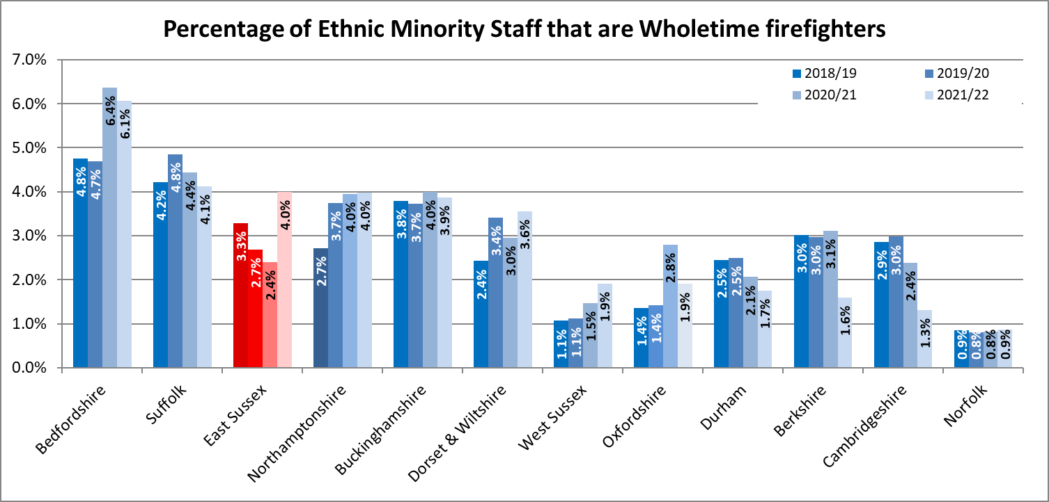
Chart 12 illustrates the percentage of wholetime firefighters that are from an ethnic minority background for FG2. As of 31 March 2022, ESFRS has the equal 4th highest proportion of ethnic minority wholetime firefighters across the FG2 members.

Chart 12: Percentage of wholetime firefighters that are from an ethnic minority. (Source - Home Office Incident Recording System, Fire statistics table 1104: Staff headcount by ethnicity, fire and rescue authority and role.)

N.B. Nationally, based on the 2021 Census, 18.9% of England’s population were classified as being from an ethnic minority background. The corresponding figures for the East Sussex County Council area was 6.1%; the Brighton and Hove City Council area: 14.6%. This combined, and therefore covering the ESFRS area, equates to 9.0%. However, this 9.0% represents the whole population and not the working demographic and includes the younger population (0-16) and older population (65+) hence the 9.0% is not comparing like with like.

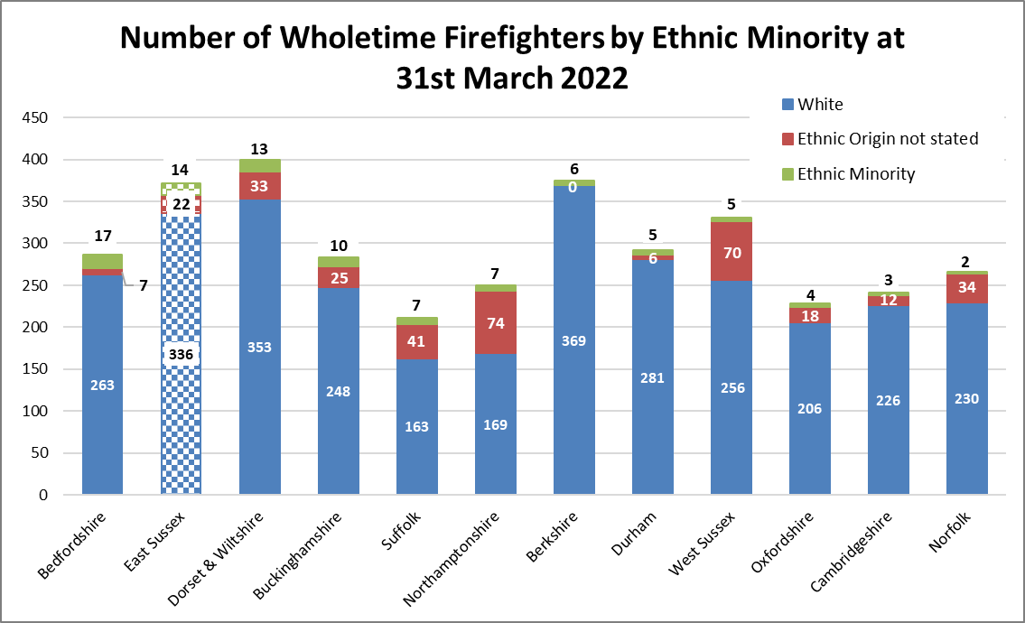
Chart 13 shows the actual numbers of white and ethnic minority wholetime firefighters by each FG2 member. ESFRS has the equal 2nd highest number of ethnic minority wholetime firefighters with 14. Bedfordshire was the highest with 17.
Chart 13: Number of wholetime firefighters that are from an ethnic minority. (Source - Home Office Incident Recording System, Fire statistics table 1104: Staff headcount by ethnicity, fire and rescue authority and role.)
Sickness
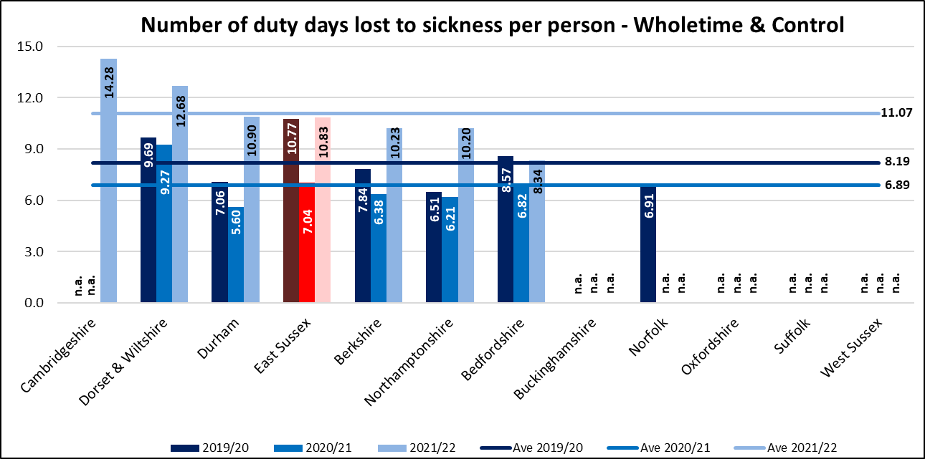
Chart 14 illustrates the number of duty days lost per person for wholetime and Control staff due to sickness. ESFRS has the 4th highest level of sickness in FG2 for 2021/22 with 10.83 days lost to sickness per employee compared to the FG2 average of 11.07. However, five FRSs from FG2 did not provide data in 2021/22. These are represented as ‘n.a.’ (not available) in the chart below where no value was returned.
Chart 14: Number of shifts lost per person due to sickness (wholetime and Control). (Source - National Fire & Rescue Service Occupational Health Performance Report April 2021 – March 2022.)

Chart 15 illustrates the number of shifts lost per person for non-uniformed staff due to sickness. ESFRS has the 4th highest level of sickness in FG2 from the 10 FRSs that provided data in 2021/22 with 8.83 days lost to sickness per employee. This figure is above the 2021/22 FG2 average of 8.10. (In the chart below, ‘n.a.’ represents no value being returned.)
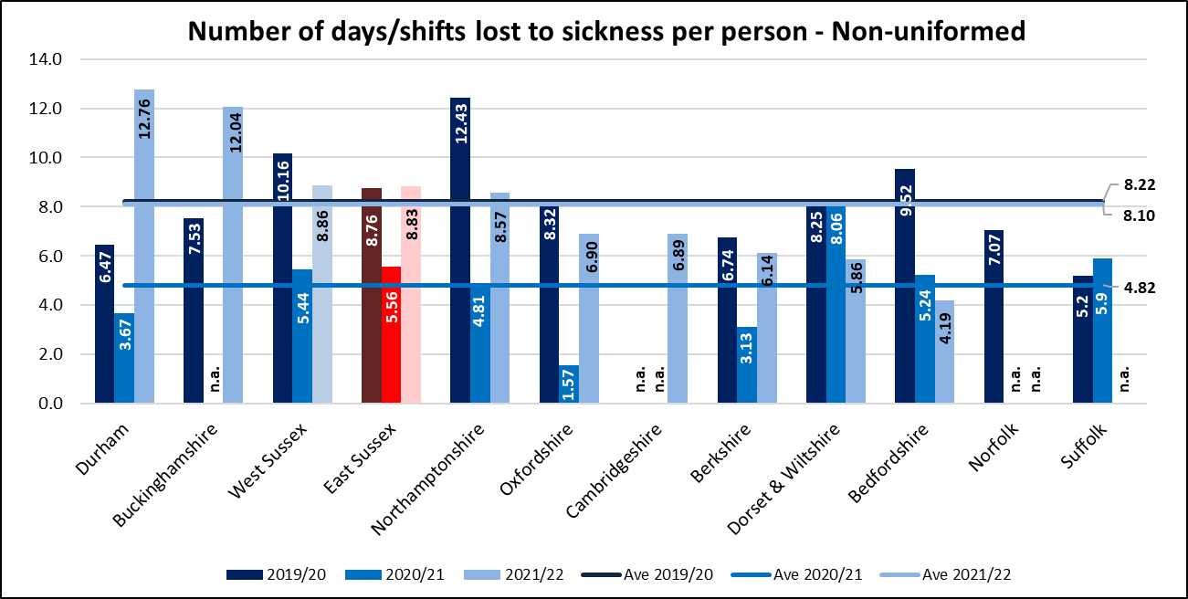

Chart 15: Number of shifts lost per person due to sickness (Support). (Source - National Fire & Rescue Service Occupational Health Performance Report April 2021 – March 2022.)

Home Safety Visits completed
Chart 16 shows the numbers of Home Safety Visits (HSVs) completed from 2010/11 to 2021/22 per 1,000 occupied dwellings for each FG2 member.
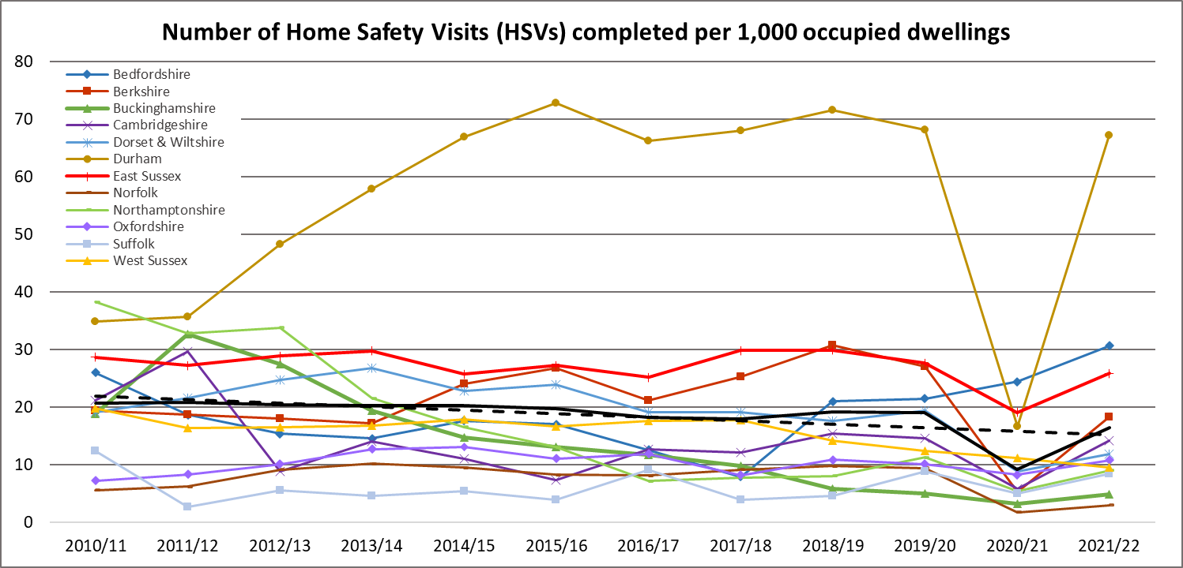
ESFRS recorded the 3rd highest number of HSVs completed per 1,000 occupied dwellings in 2021/22 with 25.8. Durham had the highest number of HSVs completed, 67.2 per 1,000 occupied dwellings. The extreme drop-off for Durham in 2020/21 was almost certainly the result of COVID 19 and the limits to house-to-house contact.
Chart 16: Number of HSVs completed per 1,000 occupied dwellings. (Source - Home Office Incident Recording System, Fire statistics table 1201: Home Fire Risk Checks carried out by fire and rescue authorities and partners, by fire and rescue authority CENSUS 2021.)

Number of Fire Safety Audits completed

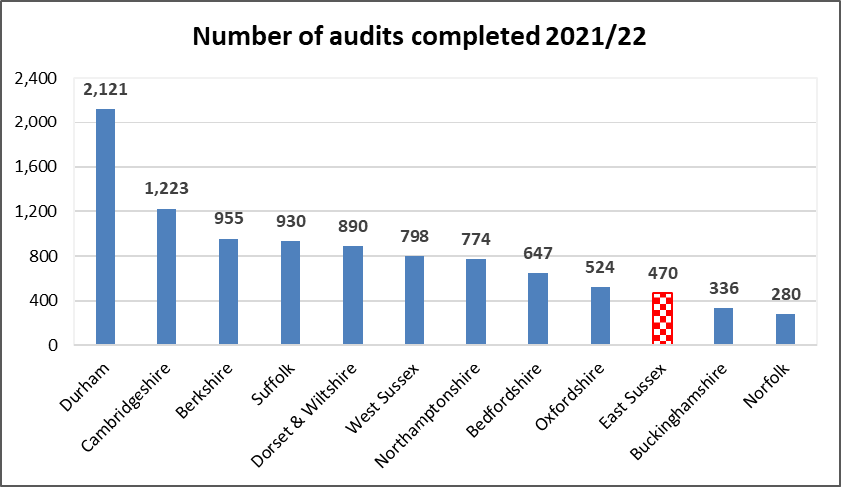
Chart 17 shows the total number of Fire Safety Audits completed by FG2 in 2021/22. ESFRS had the 3rd lowest with 470, compared to Durham with 2,121. The FG2 average was 829.
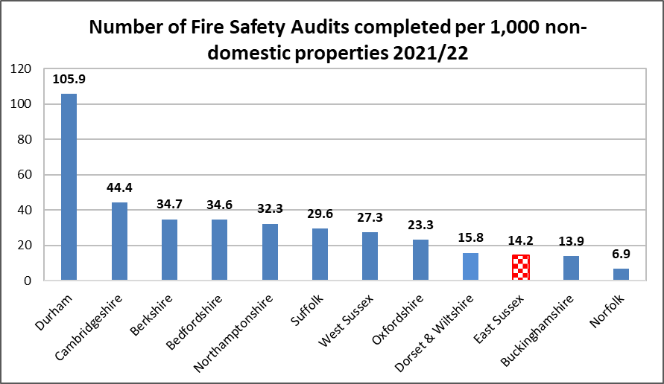
Chart 18 shows the number of Fire Safety Audits completed per 1,000 non-domestic properties in 2021/22. ESFRS completed the 3rd lowest recorded number of audits per 1,000 non-domestic properties with 14.2, whereas Durham completed the most with 105.9 per 1,000 non-domestic properties. The FG2 average at 31.9 was more than double that of ESFRS.
Charts 17 & 18: Number of Fire Safety Audits completed & Non-domestic properties. (Source - Home Office Incident Recording System, Fire statistics table 1202: Fire Safety Audits carried out by fire and rescue authorities, by fire authority & Gov UK – Non-Domestic Rating Stock of Properties 2022.)

Incident comparisons - Benchmarking

Nationally, over the past decade, the number of Fire incidents attended by FRSs has reduced, demonstrating a consistent downward trend. Since 2001/02, ESFRS has attended 65.5% less fires (5,352 in 2001/02 down to 1,849 in 2021/22). Chart 19, below, shows the reduction of Primary Fires per 1,000 population for the FG2 members from 2001/02 to 2021/22. ESFRS has had a reduction of 65.6% Primary Fires during this time, by comparison, Berkshire had the highest reduction with 70.1% and Dorset and Wiltshire the lowest with 51.4%.
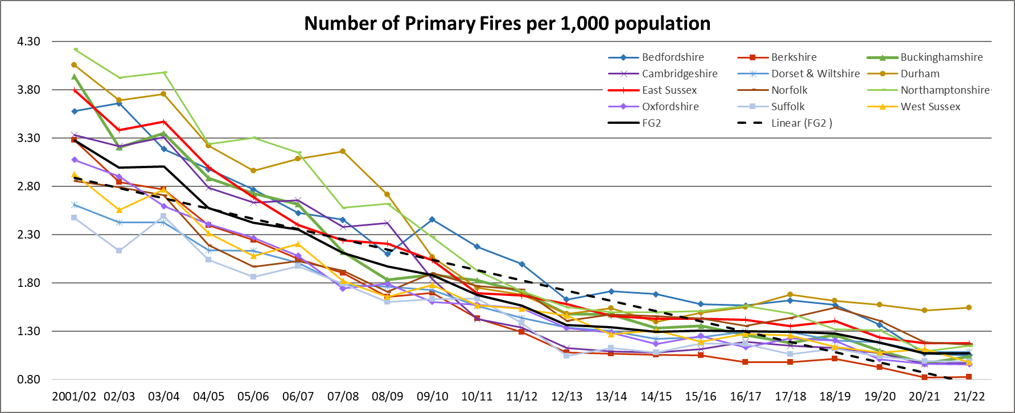
Chart 19: The number of Primary Fires per 1,000 population. (Source - Home Office Incident Recording System, Fire statistics table 0102: Incidents attended by fire and rescue services in England, by incident type and fire and rescue authority.)
Chart 20, below, shows the number of Accidental Dwelling Fires per 1,000 population for each FG2 member.

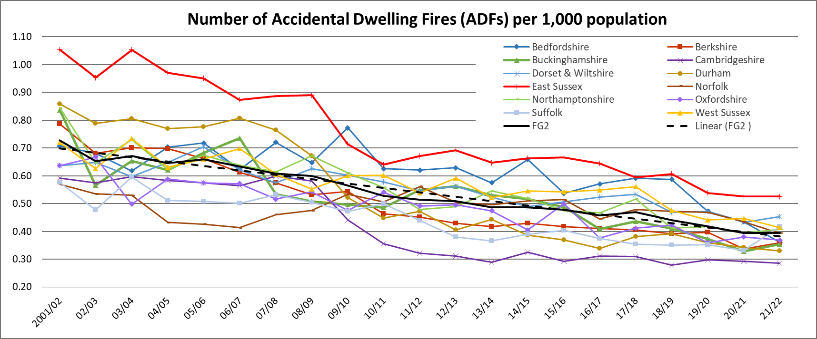
As with other Primary Fires, the number of Accidental Dwelling Fires has been reducing for a significant number of years. In 2021/22, ESFRS had 0.53 Accidental Dwelling Fires per 1,000 population. This was the highest rate in FG2.
Chart 20: The number of accidental dwelling fires per 1,000 population. (Source - Home Office Incident Recording System, Fire statistics table 0202: Fires, fatalities and non-fatal casualties in dwellings by motive and fire and rescue authority, England.)
Chart 21, below, shows the number of Deliberate Primary Fires per 1,000 population for each FG2 member.

The number of Deliberate Primary Fires has significantly reduced since 2001/02, however, this improvement has levelled off since 2013/14 but only Durham FRS has experienced an increase over the last five years.

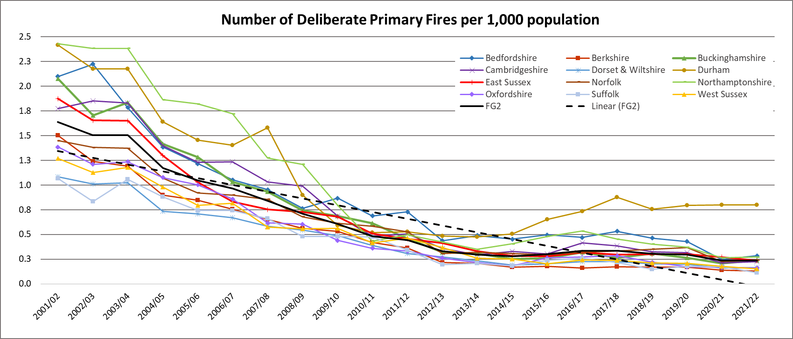
In 2021/22, ESFRS had 0.23 Deliberate Fires per 1,000 population. This was the 6th highest in the FG2 group and the same as the FG2 average.
Chart 21: The number of Deliberate Primary Fires per 1,000 population. (Source - Home Office Incident Recording System, Fire statistics table 0401: Deliberate fires attended by fire and rescue services in England, by incident type and fire and rescue authority.)

Traditionally, Deliberate Secondary Fires can be difficult to predict but clearly the level of these incidents has been reducing over recent years, along with all main incident types.

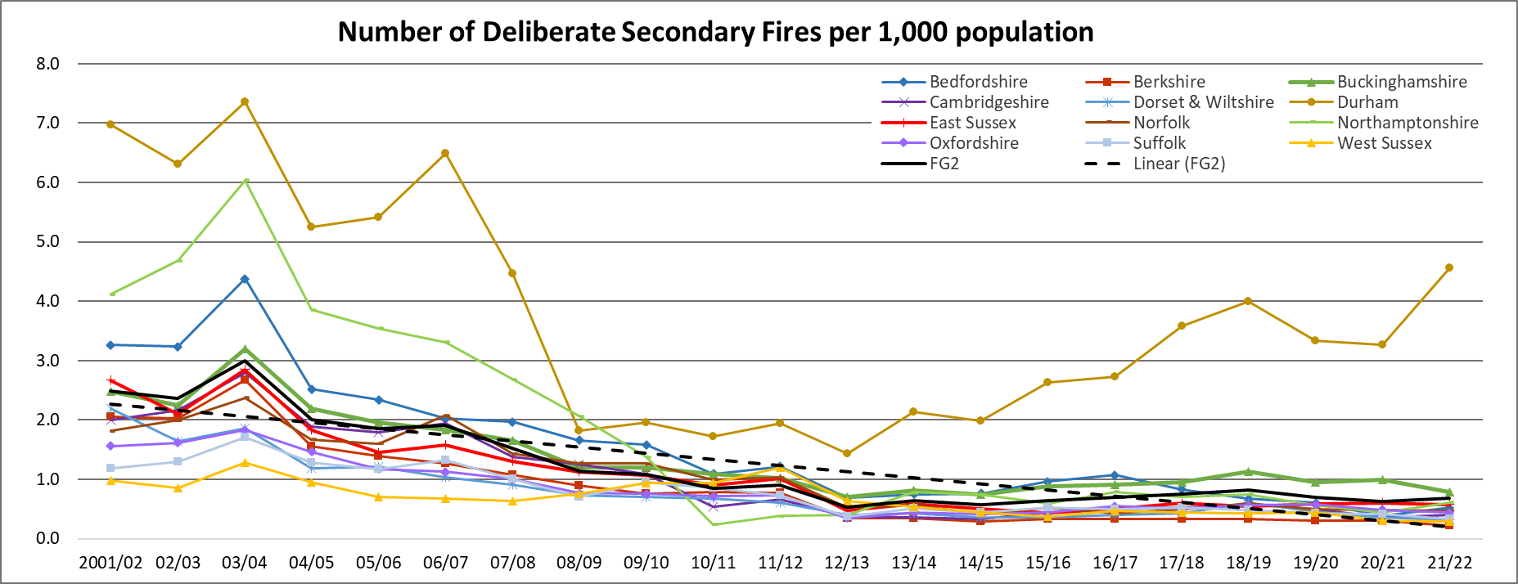
Chart 22, below, shows that the rate of Deliberate Secondary Fires per 1,000 population has reduced since 2001/02 with the FG2 average down more than two-thirds (67.6%). However, four FG2 members experienced an increase from last year. In 2021/22, ESFRS rate fell to 0.58 from 0.60 and is below the FG2 average. However, this figure is distorted by the considerable difference in numbers of deliberate secondary fires experienced by Durham.
Chart 22: The number of Deliberate Secondary Fires per 1,000 population. (Source - Home Office Incident Recording System, Fire statistics table 0401: Deliberate fires attended by fire and rescue services in England, by incident type and fire and rescue authority.)

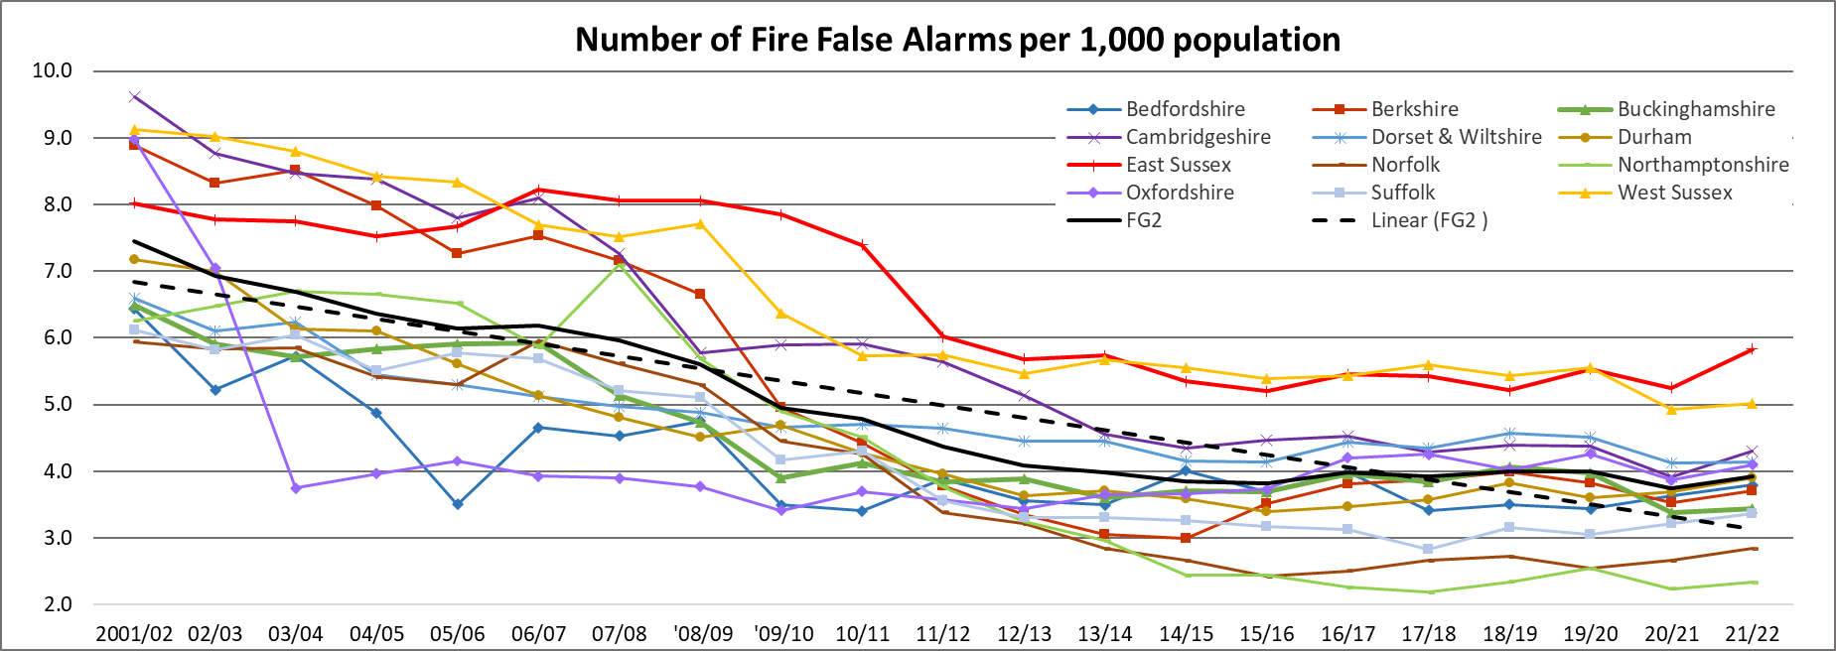
Chart 23 shows that FG2 average attendances at Fire False Alarms have been steadily reducing since 2001/02. The introduction and implementation of the Automatic Fire Alarms (AFAs) Reduction Policy at ESFRS in 2010 can clearly be seen to have reduced the overall fire false alarm numbers from 2010/11 onwards. (NB: AFAs recorded by ESFRS in 2021/22 contributed to 74% of all fire false alarms.) However, since 2012, this decline has levelled off and in 2021/22, ESFRS continues to have the highest rate (5.83) of Fire False Alarms. The FG2 average for the same period is 3.92 per 1,000 population.
Chart 23: The number of Fire False Alarms per 1,000 population (total of false alarm good intent, false alarm malicious and false alarm due to apparatus calls). (Source - Home Office Incident Recording System, Fire statistics table 0102: Incidents attended by fire and rescue services in England, by incident type and fire and rescue authority.)
Chart 24 shows the number of Road Traffic Collisions (RTCs) per 1,000 population attended by FG2 fire services since 2009/10. Based on data supplied by the Sussex Safer Road Partnership, ESFRS attends approximately a quarter of all RTCs in its service area, notably this figure could vary among the other FG2 members. Overall, RTCs have remained uniform among the FG2 group up to 2019/20 with the exception to Norfolk, which has experienced considerable variation during this period.

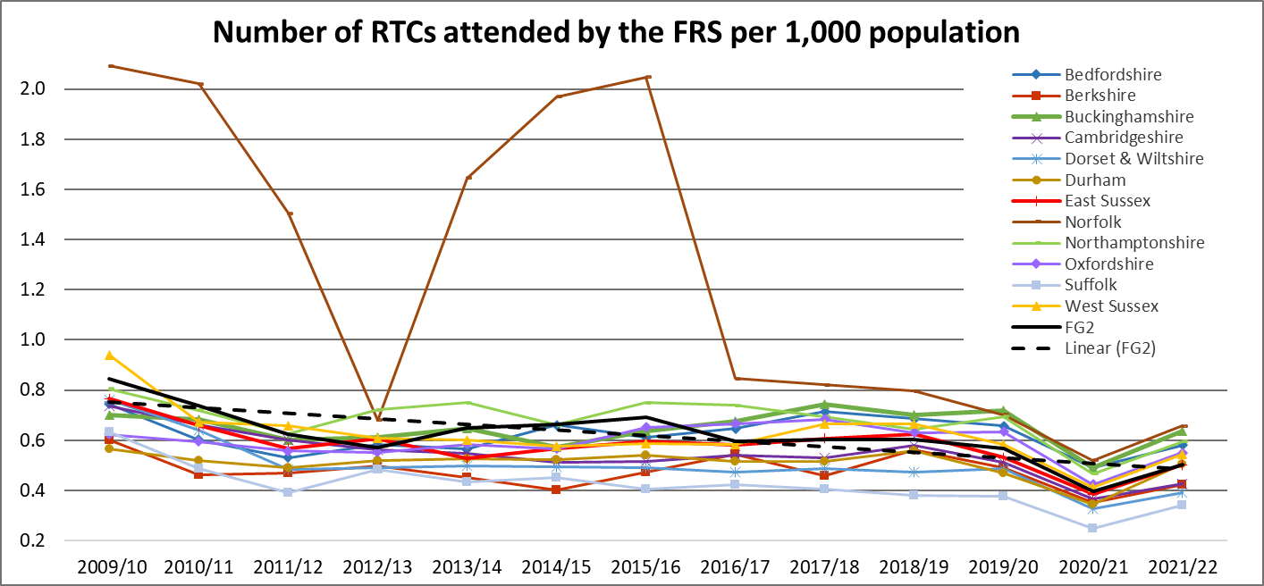
In 2021/22, ESFRS attended 0.50 RTCs per 1,000 population an increase from 0.39 in 2020/21. This was the 5th lowest among the FG2 members and below the FG2 average (0.51). This notable increase from 2020/21 was owing to the removal of COVID 19 restrictions, which included the working from home rule. Therefore, there has been a significantly increase in the number of vehicles returning to the roads in 2021/22 in line with pre-COVID conditions.
Chart 24: The number of Road Traffic Collisions (RTCs) per 1,000 population. (Source - Home Office Incident Recording System, Fire statistics table 0901: Non-fire Incidents attended by fire and rescue services in England, by incident type and fire and rescue authority.)
Chart 25 shows the number of Rescue or evacuation from water and Flooding incidents (which include, making safe, pumping out, advice only, standby and other) combined per 1,000 population since 2009/10. In 2021/22, 88% of all Flooding incidents attended by ESFRS occurred in dwellings. Overall, this data is varied, however, West Sussex, Durham and Norfolk have experienced the greatest variation during this period.

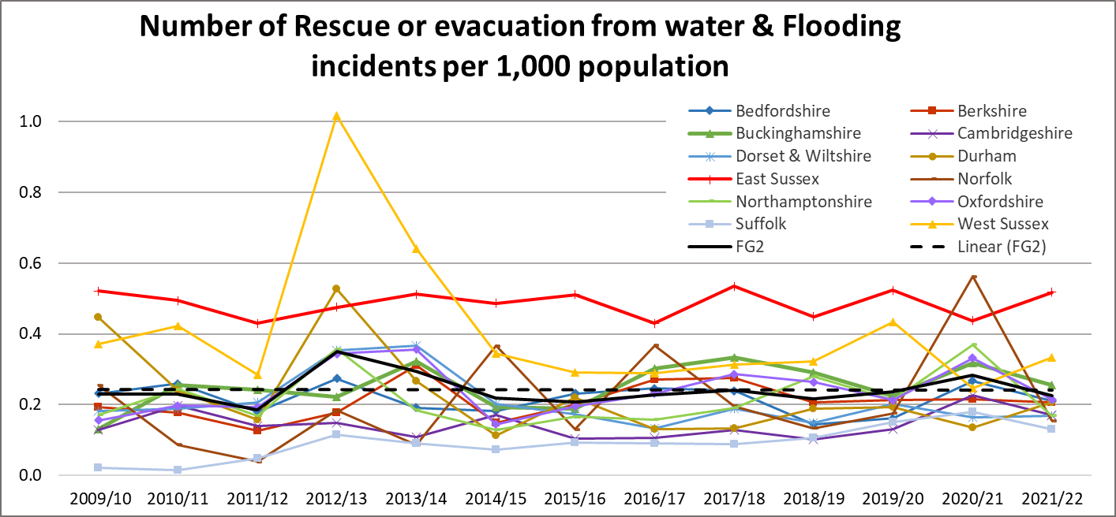
In 2021/22, ESFRS had the highest number of incidents with 0.52 per 1,000 population and twice the FG2 average of 0.23. Since 2009/10 barring three years, ESFRS has had the highest number of incidents and remains significantly above the FG2 average.
Chart 25: The number of Rescue or evacuation from water and Flooding incidents per 1,000 population. (Source - Home Office Incident Recording System, Fire statistics table 0901: Non-fire Incidents attended by fire and rescue services in England, by incident type and fire and rescue authority.)

Actual incidents: % reduction from 2001/02 to 2021/22 and FG2 rank

The following tables show the percentage reduction in actual incident numbers across all the members of FG2 from the charts provided above. The second column shows where ESFRS ranks in terms of improvement in reducing incidents over that period.

Average Response Times for all FG2 Fire and Rescue Services

Chart 26 shows the Average Response Times to dwelling fires for each FG2 member from 2009/10 to 2021/22. ESFRS is currently ranked 3rd.

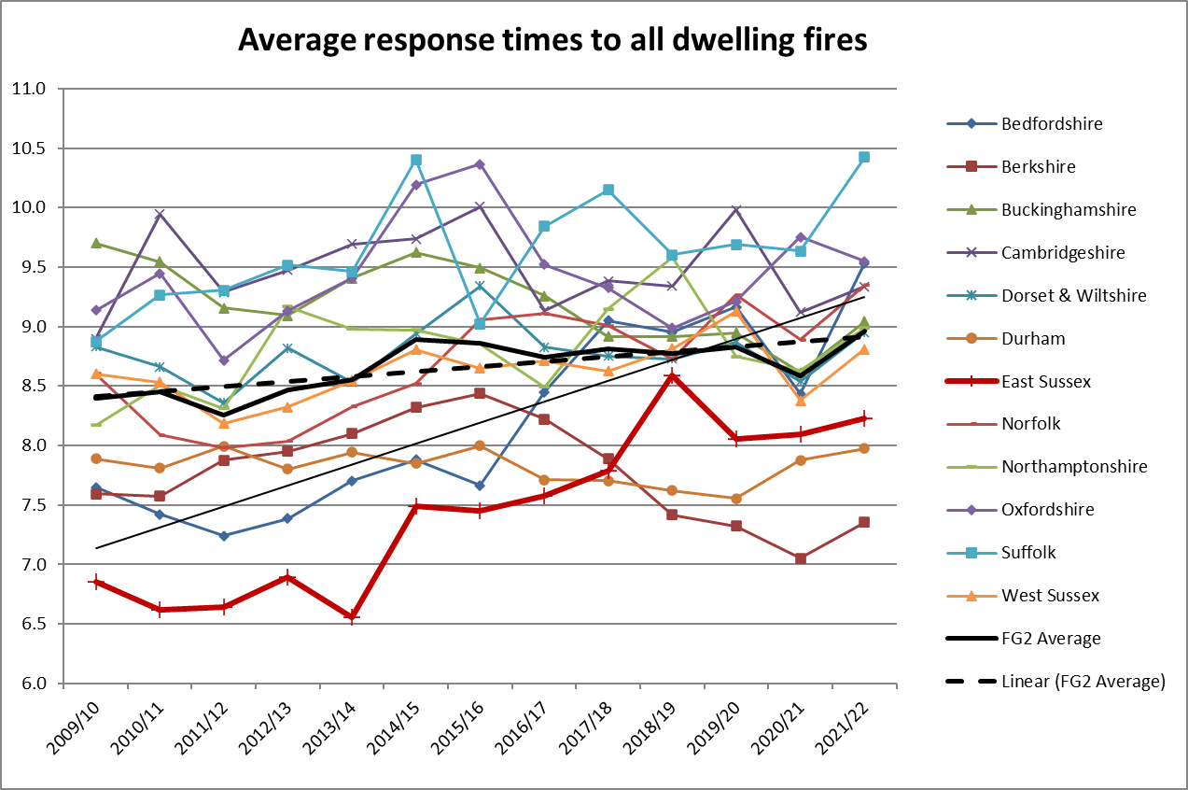
In England, the Average Response Time to fires in dwellings for 2012/13 was 7.4 minutes. ESFRS’s Average Response Time for the same year was 6.9. In 2021/22, England’s response rate increased to 7.9 minutes, whereas ESFRS increased to 8.2 minutes, therefore, now above the national average. The chart below shows that there is an increase in Average Response Times for FG2 experienced in 2021/22. ESFRS is below the FG2 average of 9.0.
Chart 26: Average Response Times to dwelling fires. (Source - Home Office Incident Recording System, Fire statistics table 1001: Average response times for dwelling fires by fire and rescue authority, England

Summary
• ESFRS, regarding population, is most comparable to Northamptonshire and Buckinghamshire; and with domestic properties (occupied dwellings) and non-domestic properties, Cambridgeshire and Suffolk respectively.
• ESFRS covers the 3rd smallest area in FG2.
• ESFRS has a senior management structure similar in size, distribution and overall numbers to Bedfordshire and Oxfordshire.
• ESFRS is above the FG2 average (20:1) for the ratio of firefighters to senior managers with 28:1. This is the joint highest with Durham.
• ESFRS has the 3rd highest percentage change in wholetime firefighters, this 4.8% increase equates to 17 wholetime operational post.
• ESFRS is 26.1% above the FG2 average number of wholetime firefighters with 372 (average 295) as of 31 March 2022 and has 17.6% less than the average On-call firefighters.
• ESFRS has a rate of 5.0 operational appliances per 100,000 population, this is above the average for FG2 with a rate of 4.2.
• ESFRS has a rate of 2.9 stations per 100,000 population this is the 5th highest in FG2.
• ESFRS has one station for every 74.8 km2, which is the highest density of stations per km2 in FG2.
• ESFRS has the highest average net expenditure cost per domestic household and the 3rd highest cost per Council Tax Band D.
• ESFRS is currently (per 100 firefighters) above the FG2 average in operational injuries, ranked 2nd highest (the same as in 2020/21) and below the average in training injuries, ranked 2nd lowest (3rd lowest in 2020/21).
• ESFRS has the 2nd highest proportion of female firefighters across FG2, with 8.9% of wholetime firefighters. This figure is above both the national average of 8.7% and the FG2 average of 7.4%. In terms of actual numbers, ESFRS has the highest number of female wholetime firefighters with 33 among FG2, up 4 from 2020/21.
• ESFRS has the 4th highest proportion of ethnic minority staff across the FG2 with 4.0%.
• ESFRS has the equal 2nd highest number of ethnic minority wholetime firefighters with 14.
• ESFRS lost 10.83 duty days per employee among wholetime and Control staff due to sickness in 2021/22, up from 7.04 in 2020/21. The FG2 average for 2021/22 is 11.07 duty days lost per employee.
• ESFRS lost 8.83 shifts per employee among non-uniformed staff due to sickness in 2021/22, which is above the FG2 average of 8.10.
• ESFRS completed 25.8 Homes Safety Visits per 1,000 occupied domestic dwellings in 2021/22, the 3rd highest among FG2.
• ESFRS completed 14.2 Fire Safety Audits per 1,000 non-domestic properties. This is the 3rd lowest among FG2.
• ESFRS has attended to 65.5% less fires (5,352 in 2001/02 down to 1,849 in 2021/22). Each FRS across the country has experienced similar reductions.
• ESFRS in 2021/22 had 0.53 Accidental Dwelling Fires per 1,000 population, which continues to be the highest rate among FG2.
• ESFRS ranks 3rd for average response times to all dwellings with 8m 14s among FG2 but is above the national average of 7m 52s.
• ESFRS attends the 2nd highest numbers of incidents overall among FG2. The incidents most attended by ESFRS involve Fire False Alarms, accounting for 45% of all incidents of which 74% are AFAs (see table 6 overleaf for total incidents attended by FG2).

Table 6 – Total Incidents attended per FRS in Family Group 2

