NON-CONFIDENTIAL REPORT
EAST SUSSEX FIRE AND RESCUE SERVICE
Agenda Item No. |  | x
Meeting |  | Policy & Resources Panel
Date |  | 18 January 2024
Title of Report |  | Revenue and Capital Budget 2023/24 and Capital Programme 2023/24 to 2027/28 Monitoring at Month 8 (end November).
By |  | Duncan Savage – Assistant Director Resources/Treasurer
Lead Officer |  | Alison Avery - Finance Manager
Background Papers |  | Fire Authority Service Planning processes for 2023/24 and beyond – Revenue Budget 2023/24 and Capital Asset Strategy 2023/24 to 2027/28  Revenue and Capital Budget 2022/23 and Capital Programme 2022/23 to 2026/27 – Provisional Outturn
Appendices |  | Appendix 1: Revenue Budget 2023/24 Objective Analysis  Appendix 2: Savings Programme 2023/24  Appendix 3: Grants and Spending Plans 2023/24  Appendix 4: Capital Programme 2023/24 to 2027/28  Appendix 5: Estates & Engineering Capital Budgets 2023/24  Appendix 6: Reserves 2023/24  Appendix 7: ITG Strategy 2023/24
Implications (please tick and attach to report)
Any implications affecting this report should be noted within the final paragraphs of the report

CORPORATE RISK |  |  |  | LEGAL
ENVIRONMENTAL |  |  |  | POLICY
FINANCIAL |  |  |  | POLITICAL
HEALTH & SAFETY |  |  |  | OTHER (please specify)
HUMAN RESOURCES |  |  |  | CORE BRIEF
PURPOSE OF REPORT | To report on the findings of the Month 8 monitoring undertaken on the Revenue and Capital Budget 2023/24 and Capital Programme 2023/24 to 2027/28.
EXECUTIVE SUMMARY | This is the fourth report to Members for the 2023/24 financial year and highlights the findings from the Month 8 monitoring undertaken on the Revenue Budget 2023/24 and 5 year Capital Programme 2023/24 to 2027/28, approved by the Authority in February 2023.  A net revenue underspend to the sum of £42,000 has been identified, as summarised in Appendix 1. This is due to the following underspends:  - Treasury Management (£723,000)  - Corporate contingency (£222,000)  - Additional funding (£159,000)  - Protection vacancies (£128,000)  - CPD for wholetime and on-call (£107,000)  - IT Project delays (£98,000)  - Communications vacancies (£54,000)  - CRM & Airbus licences (£51,000)  These are offset by the following pressures:  - Wholetime overtime within Groups (£516,000)  - Wholetime pay within Groups (£428,000)  - On-call within Groups (£157,000)  - CRM unachieved savings (£104,000)  - Payroll posts due to budget error (£98,000)  - Firelink contract uplift (£79,000)  - Unfunded pensions (£73,000)  - Procurement unachieved savings (£66,000)  - Primary datacentre relocation (£50,000)  There are a number of other small variances which contribute to the underspend.  Safer Communities are forecasting an overspend of £842,000, with the forecast overspend in Groups totalling £970,000. The forecast within Groups has not changed since P6 and whilst it was hoped overtime would start to reduce the actual spend incurred since P6 is in line with the previous forecast. There is the potential that overtime will reduce now the Flexible Resourcing Pool (FRP) is fully established and additional on-call staff are providing FRP cover. The Service must maintain a significant focus on delivering the Safer Communities action plan to reduce pressures within the department. It is anticipated some pressures will continue into 2024/25 and further analysis will be undertaken to understand what this pressure is likely to be.  Further work is required to review the forecast and management action is required in reviewing staffing and overtime forecasts.  Performance against the Savings Programme is summarised in Appendix 2 and detailed in section 5.  Performance against grants and spending plans is summarised in Appendix 3 and detailed in section 6.  Revenue and Capital programme risks are detailed in section 3, focusing specifically on areas that are subject to further investigation and the outcome could result in significant additional pressures in the current and future financial years.  The original 2023/24 Capital Budget and five year Capital Strategy of £28,280,000 was approved by the Fire Authority on 9 February 2023. The Capital Strategy has been increased to £28,793,000 to include slippage of £975,000 and allocation of spend in advance of £462,000 from 2022/23.  The current year Capital Budget was approved by the Fire Authority at £8,421,000 and updated to £8,934,000 (Property £5,665,000 and Fleet and Equipment £3,279,000) including slippage of £975,000 brought forward from 2022/23, allocation of spend in advance of £462,000 from 2022/23.  Officers have reviewed the capital plans for 2023/24 and report slippage on delivery of projects to the value of £3,911,000 (43.8%) and spend in advance of £211,000. In addition underspend of £478,000 is expected against capital schemes. The underspend has reduced by £234,000, although there are significant movements within Estates and Engineering. Detailed information is contained within section 8. The Estates and Engineering Capital Projects 2023/24 are detailed in Appendix 4.  The position on reserves shows an opening balance of £14,460,00. The forecast net drawdown from reserves is £5,724,000, a reduction of £1,569,000 compared to the planned drawdown of £7,293,000. This results in an estimated closing balance of £8,736,000, as detailed in section 10 and summarised in Appendix 6. Work is ongoing to review likely drawdown of reserves (including grants brought forward) for the rest of the current year on both Revenue and Capital projects.  There is an increase in the interest receivable on the Authority’s cash investments of £17,290,000 due to the Bank of England’s increase in base rate. Interest receivable is projected at £800,000, resulting in a surplus of £650,000 when compared to the budget. Interest payments on fixed rate loans of £9,817,000 are unaffected. Loans totalling £0.4m are due to be repaid this financial year.
RECOMMENDATION | Panel is recommended to note:  - the risks to Revenue Budget and the projected underspend,  - the forecast slippage and risks to the Capital Programme,  - the ITG strategy position  - the reduced net forecast drawdown from reserves,  - the grants available and spending plans,  - the monitoring of savings taken in 2023/24; and  - the current year investments and borrowing.

1. |  | INTRODUCTION
1.1 |  | The Original Revenue Budget 2023/24 and Capital Strategy 2023/24 to 2027/28 was approved at the meeting of the Fire Authority on 9 February 2023.
1.2 |  | This is the fourth report to Members for the 2023/24 financial year and highlights the findings from Month 8 (end November) monitoring undertaken on the Revenue and Capital Budget 2023/24 and Capital Programme 2023/24 to 2027/28. It should be noted the review is based on currently available information and the result may change as new information emerges during the year.
 | This P&R  (Month 8) | Last P&R  (Month 6) | Movement
 | £’000 | £’000 | £’000
Revenue (see section 2) | (42) | (7) | (35)
Capital in year (see section 7) | (4,178) | (4,402) | 224

1.3 |  | The Revenue Budget approved by the Fire Authority in February 2023 was a net expenditure requirement of £40,057,000
1.4 |  | A net revenue underspend to the sum of £42,000 has been identified at Month 8 (end November) and is reflected in the Revenue Budget 2023/24 objective summary at Appendix 1 and detailed in section 2.
1.5 |  | The savings requirement 2023/24 is £1,295,000. The current position shows we have delivered or are on course to deliver £1,230,000 (95%) of savings. There are two savings at risk, which also relate to prior year savings, as detailed in Section 5.
1.6 |  | The grants available total £3.983m, including grants brought forward from previous years, as summarised in Appendix 3 and detailed in section 6.
1.7 |  | The five year Capital Strategy 2023/24 to 2027/28 was approved by the Fire Authority in February 2023 at £28,280,000. The Capital Strategy has been increased to £28,793,000 to include slippage of £975,000 and allocation of spend in advance of £462,000 from 2022/23. The 5 year Capital Programme is projected to underspend by £478,000 as summarised in Appendix 4 and detailed in section 8.
1.8 |  | The Capital Budget for 2023/24 was approved by the Fire Authority at £8,421,000 and updated to £8,934,000 including slippage of £975,000 brought forward from 2022/23, allocation of spend in advance of £462,000 from 2022/23.
1.9 |  | A number of Revenue Budget and Capital Programme risks are set out in section 3 which will be monitored throughout the year. The updated position on Contingency, Reserves, Borrowing and Investments is provided at sections 7, 10 and 11 respectively.
2. |  | REVENUE BUDGET COMMENTARY
2.1 |  | The Revenue Budget is projected to underspend by £43,000. This is summarised across directorates in Appendix 1 and detailed explanations are provided below.
2.2 |  | In the previous report a forecast of £150,000 had been included for the green book pay award, based on an award of 6%.  The pay award was agreed at £1,925 and directorate forecasts have been updated to include the impact of the pay award. Budget of £120,000 has been transferred from contingency to departments to cover the pressure of the pay award above the 4% provided within the original 2023/34 budget.
2.3 |  | The total additional cost incurred in relation to the fire at the Royal Albion Hotel in Brighton is £19,000 and this is included within the forecast. Overtime costs were £6,000, with a further £7,000 on-call costs providing support and standby moves and £3,500 on recall to duty. Other spends were incurred for fuel, equipment and fireground feeding. This figure does not include costs already included within the revenue budget e.g. crews already on duty during the incident. There are no additional costs relating to over the border assistance provided by other fire & rescue services.
2.4 |  | People Services: Expected overspend of £79,000, as follows:
2.4.1 |  | HR: Expected underspend of £50,000 (previous forecast £54,000 underspend). The underspend can be attributed to staff vacancies (£31,000), drawdown from People Strategy reserve to cover EDI training (£20,000), NHS prescriptions (£3,000), training (£3,000), offset by pressures due to maternity leave cover (£3,000), interview expenses in relation to the Direct Entrant post (£2,000). There are some other small variances within the department.
2.4.2 |  | AD Admin Support: Expected underspend of £37,000 (previous forecast £36,000 underspend). The underspend relates to a vacancy, with the movement since P6 relating to the pay award.
2.4.3 |  | Service Training Centre and Workforce Development: An overspend of £72,000 is expected (previous forecast £53,000 overspend). The overspend can be attributed to on-call training (£78,000), instructor overtime (£28,000), loss of commercial training income (£27,000) and wholetime covering absences (£21,000), offset by vacancies (£69,000), timber (£5,000) where excess inflation was provided and reduced usage of scrap cars (£4,000).  The movement since P6 can be attributed to a reduction in vacancies.
2.4.4 |  | Payroll: An overspend of £80,000 is expected (previous forecast £77,000 overspend). The pressure is caused by an error in the budget for Pensions posts (£98,000) and pension advisory & interest charges (£5,000), offset by an underspend of £23,000 relating to vacancies.  The increase since P6 can be attributed to staff pay, with an individual increasing their hours.
2.4.5 |  | Occupational Health: Expected overspend of £27,000 (previous forecast to £27,000 overspend). The overspend relates to medical fees with an increased usage this year.
2.5 |  | Resources/Treasurer: Expected underspend of £57,000, as follows:
2.5.1 |  | Estates: An underspend of £1,000 is expected (previously forecast £46,000 underspend). The underspend can be attributed to pressures on reactive maintenance (£55,000) and RAAC surveys (£40,000), offset by underspends on planned maintenance (£58,000) and staffing due to vacancies (£30,000). There are a number of small variances across the department.  The movement since P6 can be attributed primarily to RAAC surveys (£40,000) with other small movements on maintenance and staffing, where a vacancy has been filled earlier than previously anticipated.
2.5.2 |  | ITG: Currently expecting an underspend of £11,000 (previous forecast £120,000 underspend). The underspend relates to project delays in Paging & Alerting, Health & Safety Management system and EDRMS (£98,000), delay in the rollout of MLL WAN services (£13,000), a reduction in CRM and Airbus licences (£51,000), reduced charges from JFC (£10,000) and reduced charges from BT due to cease dates being earlier than anticipated (£17,000). These are offset by pressures for Firelink charges, where inflation of 13.5% has been applied (£79,000), primary datacentre relocation (£50,000), additional Webex and Office 365 licences (£24,000), additional SIM cards for portable devices, caused by CRM tablets and increased mobile working (£18,000), assumed reduction in printing not realised (£8,000), staff vacancy factor not realised (£4,000), along with other small overspends and underspends across the department.  The reduction in underspend since P6 can be attributed Primary datacentre relocation (£50,000), increased WAN costs due to the faster rollout of new MLL service (£35,000) and shared MLL implementation costs not previously forecast (£27,000), CRM and Airbus licences (£37,000) offset by reductions due to BT lines being ceased (£17,000) and a reduction in Webex and Office 365 licences (£12,000) and other small movements across the department (£9,000).
2.5.3 |  | Procurement: An underspend of £12,000 is expected (previously forecast £36,000 overspend). Underspend of £42,000 is attributable to staff pay due to a vacancy and £15,000 against the consultancy budget. This is offset by an overspend of £45,000 relating to PPE where there is an expected inflationary increase of 17.1%.  The movement since P6 can be attributed to an error in the calculation of backdated pay awards and an adjustment to the vacancy period.
2.5.4 |  | Finance: An underspend of £25,000 is expected (previously forecast to budget). Underspend of £19,000 relates to insurance where savings for CCTV on vehicles were delivered earlier than anticipated and a surplus of £9,000 has been distributed by FRIC, with a further £4,000 attributable to a part time vacancy.
2.5.6 |  | Legal Services: A underspend of £10,000 is expected (previously forecast £12,000 underspend). The forecast has been amended now the Q2 invoice has been received.
2.6 |  | Planning and Improvement: A forecast underspend of £132,000 is expected as follows:
2.6.1 |  | Communications: An underspend of £64,000 is expected (previously forecast £63,000 underspend). Underspend of £54,000 relates to vacancies within the team, with a further £12,000 underspend on advert & publicity. There are small variances over a number of categories.  Since the P6 forecast additional staffing costs to support Future Foundations (£12,000) are offset by a reduction in advert & publicity (£12,000).
2.6.2 |  | Performance: An underspend of £48,000 is expected (previously forecast £92,000 underspend). The underspend can be attributed to a vacancy within the team.  The movement since P6 can be attributed to an unused budget of £44,000 for an officer to support HMICFRS inspection being moved to contingency as agreed by Senior Leadership Team (SLT).
2.6.3 |  | Cost of Democracy: An underspend of £20,000 is expected (previously forecast £13,000 underspend). Underspends on webcasting (£15,000), members allowances (£11,000) and travelling (£2,000) are offset by an overspend of £8,000 on staffing relating to a backdated pay award and maternity cover.  The movement since P6 can be attributed to a member vacancy and updates to pay forecasting.
2.7 |  | Safer Communities: An overspend of £842,000 (previously forecast £896,000 overspend) is expected with the variance detailed below.  Significant focus needs to be maintained on the Safer Communities action plan to reduce the forecast pressure for 2023/24 and to ensure that the position doesn’t impact on the 2024/25 budget. These actions include:  - Fixed term contracts being reviewed by workforce planning to ensure they are only used when absolutely necessary and considered in conjunction with overtime risks of not doing so to minimise the pressure.  - Performance measures need to be reported to ensure highly effective monitoring and approval of requests for overtime.  - Overtime is closely monitored through the year, managers should be sighted on overtime dashboard reporting.  - Review outstanding CRM savings to identify amount deliverable.  - The annual leave, sickness and light duties policies are reviewed.  - Occupational health contract is reviewed to ensure the process is conducive to ensuring staff return to work at the earliest opportunity.  Finance are attending Group meetings on a monthly basis and are working with Station Managers to support their financial understanding and provide more detailed analysis of their station expenditure.
2.7.1 |  | AD Safer Communities: An overspend of £104,000 is expected (as per P6 forecast). This pressure relates to savings as detailed in section 5.
2.7.2 |  | Groups: The Groups are reporting an overspend of £970,000 (previous forecast overspend £970,000).  The forecast for the Groups includes the IRMP changes, although there are a number of moves still in progress. Finance and HR are working closely to ensure changes are reflected within the forecast.  Whilst re-profiled last financial year, the on-call budget does not appear to reflect current activity and spend patterns across the stations and work will be completed to re-allocate these budgets in January 2024.  In November 2023 there were a total of 13 individuals on light duties, 21 individuals on long term absences and a total of 12 FTCs. It is anticipated the number of FTCs will reduce, with FTCs falling to 10 in December, with 8 FTCs currently forecasted as at March 2024. There are 5 potential ill health retirements, however the timing of these is uncertain and they remain forecasted for the remainder of the financial year.  Overtime levels have remained consistent across 2023/24 and demonstrate a reliance on overtime to cover crewing shortages. The current forecasting model which extrapolates year to date overtime based on prior year overtime profiling appears to be effective as actual costs since P6 are in line with the previous forecast and have not reduced as hoped. The Flexible Resource Pool within OSR is now fully established and is supported by on-call staff. It is not yet clear the impact that this will have in reducing overtime but it is anticipated we will have a better understanding once these individuals have been in post for a couple of months.  It is likely that some pressures will continue into 2024/25 and further analysis needs to be undertaken to understand the potential level of this pressure.  West: An overspend of £591,000 is expected. Overspend of £305,000 relates to wholetime pay, with an average over-establishment of 8.83 during the year. Additionally £234,000 overspend is due to overtime with a further £81,000 relating to on-call spend, offset by an underspend of £33,000 across wholetime and on-call.  Central: An overspend of £119,000 is expected. Overspend of £78,000 relates to wholetime pay, with an average over-establishment of 2 during the year. Additionally £150,000 overspend is due to overtime and this is offset by an underspend of £48,000 relating to on-call spend and £71,000 relating to CPD across wholetime and on-call.  East: An overspend of £260,000 is expected. Overspend of £45,000 relates to wholetime pay, with an average over-establishment of 2.33. Additionally £132,000 overspend is due to overtime with a further £124,000 relating to on-call spend, offset by an underspend of £36,000 on CPD for wholetime and on-call.
2.7.3 |  | Prevention: An underspend of £25,000 is expected (previous forecast £17,000 underspend). An underspend of £60,000 relates to vacancies within the department. These are offset by an overspend of £18,000 relating to Cadets, £17,000 overtime for Home Safety Visits and £5,000 for Soloprotect service charge which supports lone working. There are a number of other variances within the department.  The movement since P6 can be largely attributed to allocation of additional budget for pay award which includes those posts are vacant.
2.7.4 |  | Protection: An underspend of £128,000 (previously forecast £116,000 underspend). The underspend mainly relates to vacancies within the department.  The movement since P6 can be attributed to additional budget provided for the pay award.
2.7.5 |  | IRMP: An underspend of £79,000 is expected (previous forecast £45,000 underspend). This is due to a temporary Group Manager position being held vacant. The movement since P6 is a result of a decision not to recruit to the post for the remainder of the financial year.
2.8 |  | Operational Support & Resilience: A forecast overspend of £19,000 is expected as follows:
2.8.1 |  | AD OSR: An overspend of £5,000 is expected (previous forecast £5,000 overspend). The overspend can be attributed to FBU overtime for which there is no budget.
2.8.2 |  | Engineering: An underspend of £66,000 is expected (previous forecast £126,000 underspend). The underspend can be attributed to equipment, including heavy rescue equipment (£188,000), fuel (£49,000), staff (£20,000), offset by overspends on vehicle maintenance and repairs (£146,000), departmental restructuring costs (£43,000) and breathing apparatus (£4,000). There are small variances across a number of other categories.  The forecast spend has increased by £60,000 since P6, this is due to departmental restructuring costs (£43,000), which had previously been expected to be incurred in 2024/25, equipment (£19,000) including the purchase of command support wallets and specialist PPE , with a reduction for fuel based on latest prices (£8,000). There were a number of other variations where outstanding commitments were reviewed.
2.8.3 |  | Ops P&P: An overspend of £38,000 is expected (previous forecast £63,000 overspend). The overspend can be attributed to pressures in relation to hydrants (£105,000) and water rescue training (£3,000), offset by vacancies within the department (£66,000).  The movement since P6 can be attributed to a reduction in staff costs (£38,000), which mainly relates to additional budget provided for the Flexible Resource Pool, offset by an increase on hydrants (£18,000).  There was a significant peak in spend on hydrants during August (£60,000), which is the reason for the increase in forecast, which is significantly higher than previous years where hydrants have been underspent. The spend had reduced in September but has risen again since. The team are working to understand the true impact on the revenue budget.
2.8.4 |  | Control Room: An overspend of £41,000 is expected (previous forecast £101,000 overspend) based on the latest forecast received from Surrey FRS. The overspend can be attributed to staffing costs and IT systems.  Staff costs are higher than budgeted due to overtime, with additional costs for holiday pay and an extra bank holiday. The reasons for the overtime will be interrogated to determine whether there are controllable factors that can reduce future overtime levels. It is hoped the recent recruitment of bank staff will help to lower the amount.  There is also overspend on IT systems. Some of the overspend is due to the systems not being included within the budget and part is due to inflationary increases being higher than budgeted.  The movement since P6 can be attributed to a reduction in staffing costs (£10,000) and the transfer to mobilising reserve contribution (£50,000) which had been duplicated and is included within transfers to reserves budget.
2.9 |  | CFO: An overspend of £37,000 is expected (previous forecast £38,000 overspend). Overspend of £44,000 relates pay and is mainly due to the gold book pay award backdated to 1 January 2022. Additionally underspend of £9,000 is expected across a number of non-pay budgets.  The movement since P6 can be attributed to a review of non-pay budgets.
2.10 |  | Treasury Management: This budget is reporting an underspend of £723,000 (previous forecast £573,000 underspend). The interest receivable for cash investments is expected to overachieve by £650,000 due to rising interest rates, with further underspends of £70,000 on interest payable and £2,000 on MRP due to slippage of the capital programme.  The movement since P6 can be attributed to additional interest receivable of £150,000 being forecast.
2.11 |  | Non-Delegated Costs: An overspend of £275,000 is expected (previous forecast £139,000 overspend). The overspend is attributable to ill health retirements (£137,000), unfunded pension costs (£73,000) and unachieved procurement savings (£66,000) where it has not been possible to allocate against service budgets. Other small variances within non-delegated offset one another.  The movement from P6 relates to ill health retirements, with anticipated future retirements now included within the forecast. If the retirements do not happen before 31 March 2024 this will impact the outturn position. The position will continue to be monitored with HR as the year progresses.  The non-delegated budget includes the remainder of the Workforce transition budget at £77,000. This is currently forecast to budget. At this stage a total of £18,925 has been committed for 2023/24, this covers:  - £16,000 – Benenden trial  - £2,600 – DBS checks  - £325 – 360 degree feedback  Budget of £6,150 for Independent Reporting Lines has been transferred to People Services  The non-delegated budget includes the £300,000 budget for Future Foundations. This is currently forecast to budget, with a total of £267,000 committed.  It is intended any in-year underspends from Workforce transition and Future Foundations are transferred to a Future Foundations reserve at year end to fund any implementation costs.
2.12 |  | Corporate Contingency: A contingency budget of £222,000 is currently forecast to underspend and is supporting the overall forecast position.  Further information is provided in section 10.
2.13 |  | Financing: Current information indicates that the Service will receive additional funding of £159,000 (as per previous forecast).  Based on forecasts from Local Government Futures it is expected an additional £74,000 will be received for Business Rates, with a further £86,000 received in relation to council tax surpluses.
3. |  | REVENUE BUDGET AND CAPITAL PROGRAMME RISKS
3.1 |  | Pension Costs: There is continued reliance on one-off grant to fund increased contributions for FPS following the last quadrennial valuation. The most significant risk is the impact of Remedy for both McCloud / Sargeant and Matthews / O’Brien cases on the scheme valuation and employer’s contribution rates from 2024/25, which we understand the Government will cover through an additional one off grant. The Authority will be liable for any non-scheme costs including interest and unauthorised tax charges as well as any additional administrative costs. A Pension Administration reserve is held to fund costs resulting from remedy implementation. It is expected the balance of this reserve as at 31 March 2024 will be £144,000, with £72,000 committed in 2023/24 as funding for Pensions posts.
3.2 |  | Pay Award 2023/24: The budget provided for 4% pay awards across gold, grey and green book staff.
3.2.1 |  | Gold book pay awards backdated to January 2022 are included within the reported forecast position.
3.2.2 |  | Grey book staff have been awarded 7% from 1 July 2022 and 5% from 1 July 2023, which is included within the forecast position.
3.2.3 |  | Green book staff have been awarded £1,925 from 1 April 2023, which is included within the forecast position. £120,000 has been allocated from contingency to cover the pay award.
3.3 |  | Worldwide Supply Chain Issues: The impact of worldwide supply chain disruption is impacting construction projects across the nation. The dwindling supplies along with increased costs and long delivery times being experienced by the construction industry are impacting on the Capital Programme. Thus far the Estates team has worked with stakeholders to bring tender costs back within budget through value engineering where possible on those projects which the Authority committed to following the phase 1 review of the Estates Capital Programme, but this approach may not be sustainable. There are two potential impacts, firstly increases in the cost of projects and secondly slippage of projects and spend into future years (which could in itself lead to additional increased costs). The Estates Team has completed an initial review of the capital programme and SLT has agreed priorities for delivery to the end of 2024/25 (which will be reflected in the draft budget report to January P&R Panel) and will carry out a full review of the Estates Strategy in 2024/25. Additional funding has been agreed to address inflationary pressures on the Preston Circus project (£1.6m) and new funding for Fort Rd Engineering Workshop (£0.5m). These will be reflected in the 2024/25 budget papers.
3.5 |  | Inflationary Contract Increases: In addition to utilities and fuel additional budget provision was allocated for maintenance and term contracts (£70,000), legal services (£4,000) and catering (£6,000). A standard 2% inflationary budget increase was included for all non-pay totalling £181,000. This there is a risk pressures will arise across non pay spend budgets that cannot be absorbed. This position will continue to be monitored with input from Procurement.
4. |  | MANAGING REVENUE BUDGET PRESSURES
4.1 |  | As risks crystalise the resulting pressures will be included within the revenue budget forecast. A number of areas require further analysis to identify further pressures or opportunities.
4.2 |  | SLT has agreed the following controls are put in place for 2023/24:  - Workforce Planning Group will be used as a mechanism to:  - Approve recruitment to all vacancies  - Approve the use of agency staff  - Have oversight of overtime spend (with a particular focus on Safer Communities & Training)  - Review and agree forecasts for operational (grey book) strength.  - Management of discretionary spend to be a key focus, with Finance Business Partners working with budget managers to review opportunities to manage underspends on non-pay spend in 2023/24 with particular focus on areas such as training, estates maintenance and equipment (IT and Engineering).
5. |  | SAVINGS PROGRAMME 2023/24
5.1 |  | Appendix 2 summarises the net savings requirement 2023/24 of £1,295,000. Work is in ongoing with Service managers to identify and report actual delivery of savings compared to budgeted savings.
5.2 |  | Current projections show we have delivered or are on course to deliver £1,230,000 (95%) of savings.  Procurement savings of £66,000 (£15,000 2023/24 and £51,000 prior year) have not been allocated and are causing a pressure. It has been agreed this saving will be removed as part of 2024/25 budget setting.  A pressure of £104,000 within Safer Communities (£50,000 2023/24 and £54,000 prior year) relating to CRM will be removed as part of budget setting for 2024/25. The CRM project resulted in a reduction in 4 posts, however these budget reductions were not allocated correctly against CRM at the time. There will be a further review through Future Foundations to identify any further efficiencies.
6. |  | GRANTS 2023/24
6.1 |  | The Government has awarded grants for use on specific purposes and your officers will ensure these are delivered in accordance with grant conditions. These include grants awarded in year, brought forward from previous years where their spending plans fall over more than financial year and others that require development of spending plans. The amount available is £3.983m, as summarised in Appendix 3.
6.2 |  | The latest grants are detailed below:
6.2.2 |  | Surge Protection Grant Funding: – this is specifically to deal with inspections for high rise buildings and other high-risk buildings. The grant conditions have been received. A further allocation of £358,079 has been awarded for 2023/24. A spend plan has been developed to utilise this grant and it is expected £104,000 will be drawn down from the £125,645 brought forward from 2022/23.
6.2.4 |  | Accreditation & RPL Grant Funding: £22,737 is carried froward from 2022/23 for the purposes of accrediting fire protection officers and fire safety engineers. It is anticipated this grant will be utilised over the next two years.
6.2.5 |  | Fire Fighter Pension Scheme: this is used towards the shortfall in employer’s pension contributions.
6.2.6 |  | New Dimensions: £47,667 is carried forward from 2022/23 and additional £27,430 grant relates to 2023/24. A spending plan has been developed and it is expected £54,231 will be spent this year, with the balance of £20,866 carried forward to 2024/25.
6.2.7 |  | Responding to New Risks: £31,355 is carried forward from 2022/23, and additional £6,500 grant relates to 2023/24. A spending plan has been developed and it is expected £37,111 will be spent this year, with the balance of £744 carried forward to 2024/25.
7. |  | CONTINGENCY 2023/24
7.1 |  | The Fire Authority maintains a contingency in order to assist it in managing one-off unforeseen pressures and making investments within the financial year. At its meeting held in February 2023, the Fire Authority agreed a contingency of £533,000 for the 2023/24 financial year. This included the general 2% inflation provision of £181,000 which has not been allocated out to relevant non pay spend budgets.
7.2 |  | The contingency increased by £336,000 as approved by SLT and brings the total amount available to £913,000.  Commitments approved to date total £691,000 for the grey and green book pay awards, leaving a contingency balance of £222,000 as at the end of November as detailed in the table below:  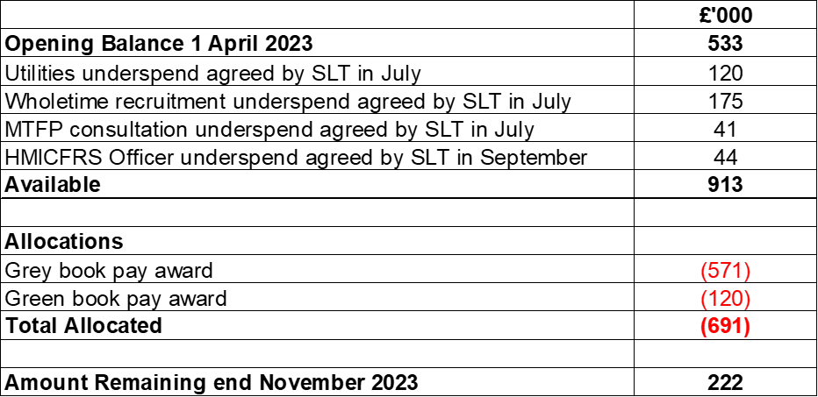
8. |  | CAPITAL PROGRAMME COMMENTARY
8.1 |  | The original 2023/24 Capital Budget and five year Capital Strategy of £28,280,000 was approved by the Fire Authority on 9 February 2023. The Capital Strategy has been increased to £28,793,000 to include slippage of £975,000 and allocation of spend in advance of £462,000 from 2022/23.
8.2 |  | The Capital Programme is funded by: Capital Receipts Reserve £626,000, Capital Programme Reserves £13,895,000, and New Borrowing £13,794,000 as shown in the table below. Overall, the revised 5 year Capital Programme is forecasted to come in £478,000 underspent.  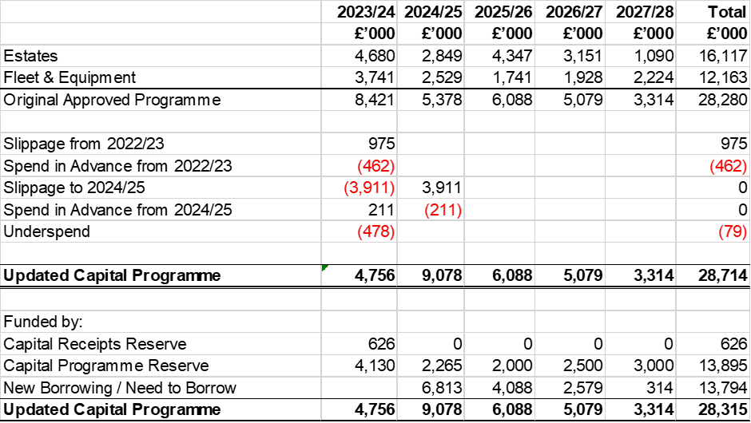
8.3 |  | Capital Funding – The Service has also been successful in its bid for Community Infrastructure Levy (CIL) funding from Lewes District Council. £289,000 has been awarded which will part fund the planned enhancements at Barcombe and Seaford Fire Stations, reducing the need for future borrowing.
8.4 |  | The Capital Budget 2023/24 was approved by the Fire Authority at £8,421,000 and updated to £8,934,000 (Property £5,655,000 and Fleet and Equipment £3,279,000) including slippage of £975,000 brought forward from 2022/23 and allocation of spend in advance of £462,000 from 2022/23.
8.5 |  | A review of the 2023/24 capital budget by officers has identified slippage to the value of £3,911,000 (46.4%) and spend in advance of £211,000. There is additional underspend of £478,000 expected, as summarised in Appendix 4.
8.5.1 |  | The Estates / Property underspend is £2,985,000, of which £3,088,000 is slippage due to the reprioritisation and reprofiling of works and £103,000 relates to spend in advance. Work has been delayed in relation to Preston Circus, Roedean, Eastbourne, Bohemia Road, the four MPTH, Security, Sustainability, Training Towers, Bay Doors, Floors and IT Building works.  The underspend has reduced by £1,234,000 since P6, which can be attributable to work at Preston Circus expected to start earlier than previously anticipated against an increased scheme budget, with a number of other smaller movements across the programme.
8.5.2 |  | The Fleet underspend is £1,193,000. There is slippage of £823,000, relating to 3 ancillary vehicles, 6 vans including the Fire Investigation and Hazmat vans, and £67,000 relates to a decision to pause the purchase of pool cars whilst a review is undertaken, with a further £35,000 relating to IRMP equipment. Spend in advance of £1208,000 relates to the water carrier, where budget was previously slipped to 2024/25 during budget setting. Underspend of £478,000 relates to six vehicle purchases, CCTV installation and equipment.  The forecast position includes the decision to capitalise 80% of the Vehicle Build Officer costs, however at this stage this is shown separately and will be allocated against projects in due course.  The forecast spend has reduced by £1,000,000 since P6. Underspend of £371,000 relates to two aerial purchases which have now been completed. Additional slippage of £646,000 relates to a number of vehicles, some of which will not now be delivered until the new financial year and some of which are as a result of the decision by SLT to extend the useful life of light fleet, thus deferring the replacement purchases.
9 |  | IT STRATEGY 2023/24
9.1 |  | A review of the 2023/24 IT Strategy forecasts indicates a total of £2.030m will be drawn down from the reserve this year, against an original plan of £5.268m. The main slippages relate to Process Digitisation (£301,000), ESN (£1.425m), Finance System Improvement/Replacement (£172,000), Health & Safety system (£123,000), Pagers and Alerters (£428,000), Telephony (£270,000) and Laptop Lifing (£250,000). The full breakdown can be seen in Appendix 7.  There has been a reduction of £262,000 since P6, which can be attributed to Finance System Improvement/Replacement (£172,000), Information Security (£56,000) and IT outsources re-tender (£34,000) due to project delays, with spend expected to be incurred in 2024/25 and 2025/26.
10 |  | RESERVES 2023/24
10.1 |  | The Fire Authority maintains Reserves in order to assist it in managing its specific spending plans across the financial year (Earmarked Reserves), making provisions for the financial risks it faces (General Fund Reserves) and making investments (Capital Receipts Reserve).
10.2 |  | The opening balance of reserves at 1 April 2023 is £14.460m.
10.3 |  | The forecast net drawdown from reserves totals £5,724,000 compared to the original planned net drawdown of £7,293,000. This is a net reduction in drawdown of £1,569,000 resulting in an estimated balance at 31 March 2024 of £8,736,000 as summarised in the table below and detailed over individual reserves in Appendix 6.  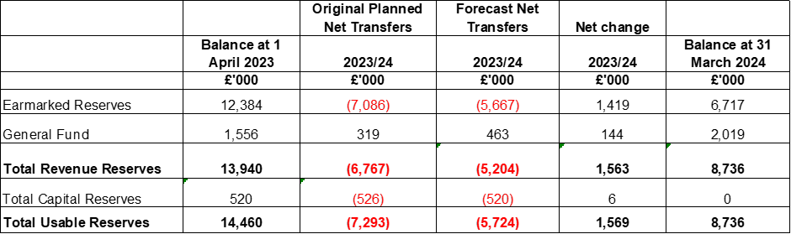
10.4 |  | Work continues with budget managers to confirm the planned use of revenue and capital reserves in 2023/24.
10.5 |  | The main reasons for the overall net reduction in forecast drawdown of £1,542,000 are as follows:  Earmarked Reserves – Decrease of £1,473,000  - £627,000 – changes to drawdown from Business Rates Pool Reserve based on P8 budget monitoring forecast for Protection spend, changes to contribution into the pool for 2022/23 and forecast of contribution into the pool for 2023/24  - (£25,000) – increased drawdown from Mobilising reserve  - (£73,000) – increased drawdown from the Improvement & Efficiency reserve  - £776,000 – reduced drawdown from the Capital Programme Reserve  - (£71,000) – increased drawdown from the Covid reserve  - £44,000 – reduced drawdown from the Carry Forward Reserve  - (£1,000) – increased drawdown from cadets reserve  - (£147,000) – increased drawdown from People Strategy reserve  - £6,000 – reduced drawdown in respect of grant balances carried forward  - £169,000 – reduced drawdown from the ITG strategy reserve  - £33,000 – reduced drawdown from the Pensions Administration reserve  - £81,000 – contribution to Future Foundations reserve  General Reserve – Increase of £144,000  - £144,000 – increased contribution to general reserve from 2022/23 underspend on wholetime recruitment previously held in People Strategy reserve  Capital Reserves – Decrease £6,000  - £6,000 – due to balance of Capital Receipts Reserve being lower than anticipated when the budget was set and additional capital receipts received during 2023/24.
11. |  | BORROWING AND INVESTMENT
11.1 |  | As at end November, the Authority held cash balances of £17,290,000 which were invested in accordance with the Treasury Management Strategy, as follows:  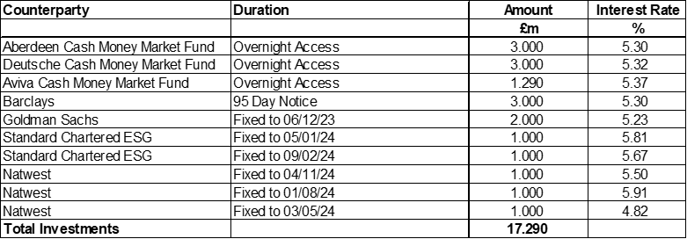
11.2 |  | The Bank of England base rate rose 0.25% to 5.25% in August. We are continuing to see an impact as Banks increase their rates on investments, resulting in higher levels of interest receivable. Latest modelling indicates the income of around £800,000 can be achieved, £650,000 above the budgeted level of £150,000.
11.3 |  | The current forecast of a reduction in reserves of £5.751m means that the Service will need to monitor its liquidity and cashflow closely during the year and this may involve giving notice on some of its existing investments. Finance continues to work with the ESCC Treasury Management team to improve cash-flow monitoring.
11.4 |  | The Authority’s borrowing has reduced to £9,581,000, with the repayment of 2 loans totalling £236,000 in September 2023. The increase in base rate does not impact the interest payable on outstanding borrowing as these are subject to fixed interest rate deals.  No further borrowing is expected this financial year.
Appendix 1
Revenue Budget 2023/24 – Objective Summary
 |  | 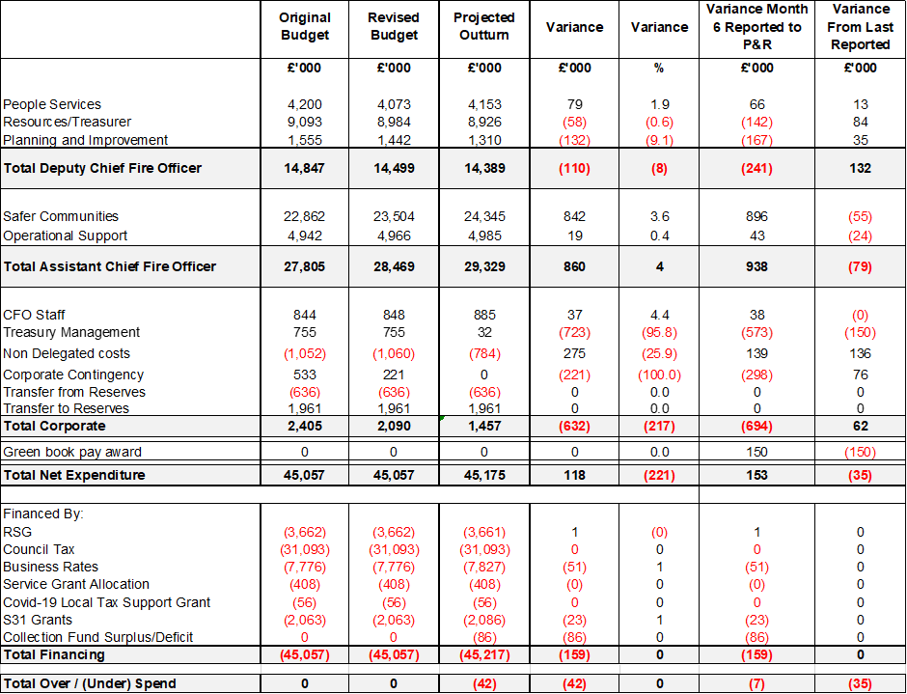
Appendix 2
Savings Programme 2023/24

Appendix 3
Grants and Spending Plans 2023/24

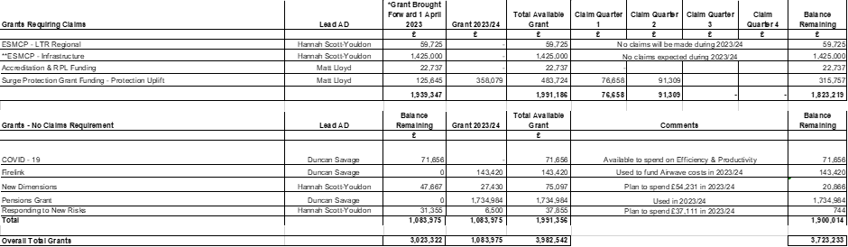

Appendix 4
Capital Programme 2023/24 to 2027/28

Appendix 5
Capital Programme 2023/24

Appendix 6
Reserves 2023/24

Appendix 7
ITG Strategy 2023-24

