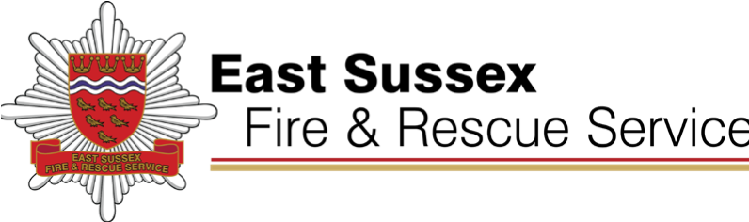
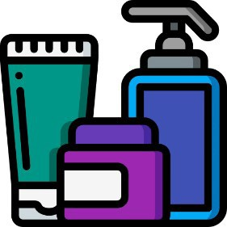
Emollient Creams pose a significant fire risk. They can impregnate clothing and bedding making them particularly inflammable. If you use emollient creams to treat skin conditions please note the following:
Fire Safety Advice

for clients who use emollients
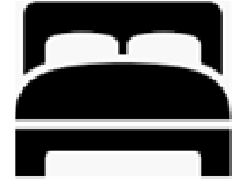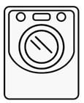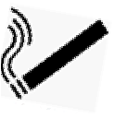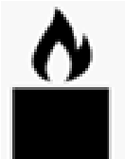
  - Do not smoke or use naked flames (or be near people who are smoking or using naked flames).
  - Do not go near anything that may cause a fire while emollients are in contact with their medical dressings or clothing. For example, do not lean over a lit gas cooker hob or candles, or allow lit cigarettes to come into contact with clothing or dressings.
  - Clothing and bedding should be changed regularly - preferably daily - to reduce the buildup of emollient within the fabric.
  - Wash fabrics at the highest temperature indicated on the care instructions to try and remove any residue. This may reduce the risk but will not eliminate it. Do not dry these fabrics on or in front of heaters. If using a tumble dryer use a cooler temperature setting and ensure it runs the full cycle including the cool down cycle. Allow items to cool fully before folding to allow any heat to dissipate.
For Further Advice please contact the Community Safety Department on 0800 177 7069 or visit our website at www.esfrs.org
□ Close inside doors at night to stop a fire from spreading.
□ Turn off and unplug electrical appliances unless they are designed to be left on – like your freezer.
□ Check your cooker is turned off.
□ Don’t leave the washing machine or tumble dryer on.
Bedtime
checklist
□ Turn heaters off and put up fireguards.
□ Put candles and cigarettes out properly.
□ Make sure exits are kept clear.
□ Keep door and window keys where everyone can find them.
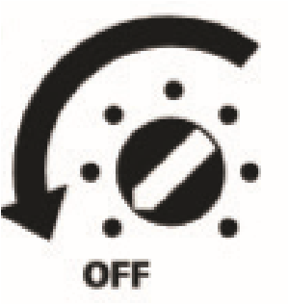
Updated Sept 2025

