APPENDIX A



Annual Performance
Outcome Report for
2021/22

AUGUST 2022

Contents

Section |  | Page No.
1 | Introduction | 2
2 | Operating Environment | 3
3 | Summary of Achievement | 4
4 | Performance Results 2019/20 | 5
 | Our Purpose: We make our communities safer | 6
 | 4.1 Commitment 1: Delivering high performing services | 6
 | 4.2 Commitment 2: Educating our communities | 7
 | 4.3 Commitment 3: Developing a multi-skilled, safe and valued workforce | 8
 | 4.4 Commitment 4: Making effective use of our resources | 9
5 | Detailed Performance Analysis | 10
 | 5.1 Primary Fires | 10-12
 | 5.2 Accidental Dwelling Fires | 13-15
 | 5.3 Deliberate Fires | 16-20
 | 5.4 Primary Fire Fatalities and Injuries | 21
 | 5.5 Sickness Indicators | 22
 | 5.6 Health and Safety | 22
 | 5.7 Level 3 & 4 Incidents attended in 2020/21 | 23
6 | Compliments and Complaints  Appendix B: Plain English descriptions of indicators | 24-26  27-29

1. Introduction

This report provides details of East Sussex Fire & Rescue Service’s (ESFRS) performance for the period April – March 2021/22.

It provides a transparent, single view of information which allows Elected Members, Auditors and members of the public to hold the Service’s senior managers and staff to account in terms of the provision and performance of their Fire & Rescue Service for 2021/22.

The Fire Authority’s purpose is to ‘make our communities safer’. We have developed four overarching commitments to the public as follows:

Our Purpose is: We make our communities safer

Our Commitments are: Delivering high performing services
Educating our communities
Developing a multi-skilled, safe and valued workforce
Making effective use of our resources

Our Core Values are: Proud
Accountable
Integrity
Respect

2. Operating Environment

ESFRS provides prevention, protection and response services to 832,000 people living in 361,500 households within the area of East Sussex and the City of Brighton & Hove. We work within a large and diverse area on the south coast of England, covering rural locations as well as a busy city centre and urban seaside towns.

The County of East Sussex experiences high levels of deprivation when compared to other counties in the South of England. Our larger towns and the City of Brighton & Hove are very popular tourist destinations and the summer population is enhanced significantly, with over 8 million visitors, along with the risk of fire and road traffic collisions. The main headlines for the Service’s area are:

Coastal and other influences

- At least 70% of the population lives along 47 miles of coast
- Our area provides almost every aspect of community risk including multiple harbours, with the inherent risk of ship fires and oil terminals leading into the city of Brighton & Hove
- The influence of the landscape and significant coastal and inland flooding causes risks
- ESFRS service area has an older age profile compared to England and the South East with 22.1% aged 65 or over, compared to 18.6% in England and 19.4% regionally.
- ESFRS service area is below the national average for adults classified as physically inactive (23.4%) with 20.5% adults classified as physically inactive. Eastbourne is the only borough above the national average with 24.5%.
- East Sussex has no motorways and all the main ‘A’ roads suffer from congestion and traffic problems. ESFRS service area had a 26.7% increase in ALL recorded road casualties from 1 April 2021 to 31 March 2022: 2,266 up from 1,788. This is clearly due to a return to near normal conditions after the lockdowns experienced during 2020-21 caused by COVID-19.
- It is estimated that 10.7 million tourism day trips were made to Brighton & Hove in 2019, of which 1.67 million were overnight visitors. In total, around £976.4 million was spent on trips to Brighton and Hove in 2019 by overnight and day visitors, up by 13% compared to 2018.

* CENSUS 2021 (2022): Population and household data; East Sussex Local Transport Plan 3 2011-2026; The volume and value of tourism 2019, Tourism South East Research; SSRPs Data Portal /Crashes monthly data; and Public Health 2020/21 - Physical Activity.
3. Summary of Achievement

The table below provides a key summary of our achievement against targets, or where no target is set, our achievement against the previous year’s result in our priority areas, and non-priority areas for 2021/22.

Our priority areas for 2021/22 were:
☑ Reducing accidental dwelling fires
 Responding quickly to a fire to stop it spreading from the room it started in
 Reducing false alarm calls, especially in properties with a previous history of this
 Increasing the number of home safety visits that we complete with the more
  vulnerable members of our community
 Reducing the number of absences of our employees due to sickness
☑ Increasing inspections in high-risk premises and business audits carried out by station crews (Priority 7 and 7a combined)
☑ Numbers of home safety visits
Due to the limitations imposed by the COVID-19 restrictions during 2020/21 ESFRS continued to find other ways of undertaking home safety visits, business safety audits and engagements. Then on 19th July 2021 in line with the lifting of Government restrictions the service began face to face engagements. Therefore this report includes all indicator results, but only shows the previous year comparison against 16 of the total 21.

Indicator group |  | Indicators where the target has been met or performance exceeded the previous year |  | Indicators where target has not been met or performance declined against the previous year
Priority Areas | 1  (6%) |  | 4  (25%)
Non-priority areas | 7  (44%) |  | 4  (38%)
All Indicators | 8  (50%) |  | 8  (50%)

As can be seen from the above table, in 2021/22, 1 from 5 (20%) Priority Areas; 7 from 11 Non-priority (63%); and 8 from 16 (50%).
☑ Achieved
 Not achieved

4. Performance Results 2021/22

The following section contains the results against our strategic objectives. The tables give a comparison against last year’s performance, whether or not the target was achieved and the direction of travel from the previous year.

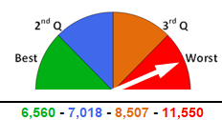 | This diagram compares ESFRSs’ results against the rest of the Fire and Rescue Services in England. Each of the four quarters represents the scale of best to worst performance based on Home Office results 2020/21*. The arrow represents ESFRS ranking within these quartiles.  In this illustrative example, using the current total number of incidents, ESFRS is in the fourth quartile. To reach quartile 3, ESFRS needs to reduce total incidents to a total equal or below 8,507; quartile 2, equal or below 7,018 and quartile 1, equal or below 6,560.  * 2021/22 results have not yet been published.

Our Purpose: We make our communities safer

4.1 Commitment 1: Delivering high performing services

We will do this by:

4.2 Commitment 2: Educating our communities

We will do this by:

4.3 Commitment 3: Developing a multi-skilled, safe and valued workforce

We will do this by:

4.4 Commitment 4: Making effective use of our resources

We will do this by:

5. Detailed Performance Analysis

After analysing the overall performance information, we have identified a number of key indicators which we have undertaken additional and more detailed analysis upon.

These key indicators include:
- Primary Fires
- Accidental Dwelling Fires
- Deliberate Fires
- Primary Fire Fatalities
- Primary Fire Injuries
- Sickness Indicators
- Health and Safety

This analysis has looked at the following:

- Performance against previous year
- Main Types and causes of incidents
- Geographic analysis of the location of incidents.

The results of this detailed analysis are reported in the following section.

5.1 Primary Fires

Performance April-March 2021/22: 967 Fires

Reduced ✓ by 3.0% (30) since 2020/21 from 997 to 967 fires.
Reduced ✓ by 38.8% (614) since the 2009/10 baseline of 1,581.

Main Types of Primary Fires

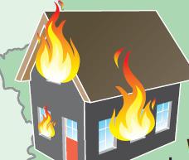49% (473) Dwelling Fires | 20%  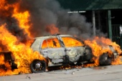  (191) Vehicle Fires | 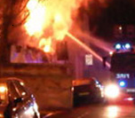12% (114) Industrial/ Commercial Fires | 19% (189) Other/  Outdoor Fires

Main Cause of Fires

20.0% (193) were Deliberate

80.0% (774) were Accidental or Not known (main causes: Cooking with 138 incidents; Fault in equipment or appliance, 125; Overheating, unknown cause, 94; Faulty fuel supply - electricity, 87; Combustible articles too close to the heat source (or fire), 80; Careless handling, 64; Accumulation of flammable material; 48.

Primary Fires % change from 2020/21 to 2021/22 by Geographical Area

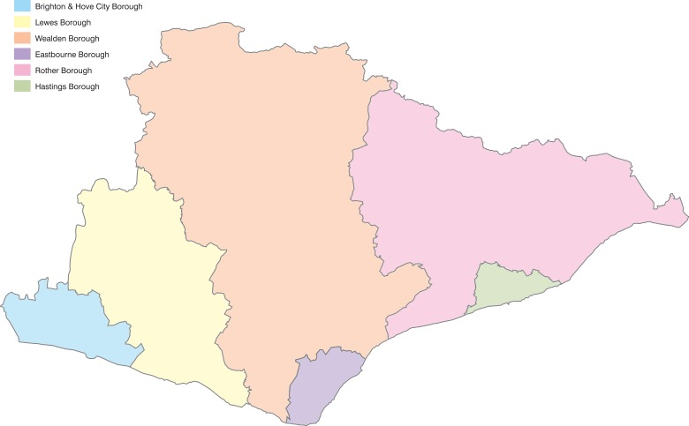

-3%
-13%

6%
8%
8%

-30%

Additional information for decreases or increases in Primary Fires from 2020/21 to 2021/22
Eastbourne had the largest proportional and total decrease in Primary Fires with 30% and 53 respectively.
Brighton & Hove had the largest total increase of Primary Fires with 24 and the equal largest proportional increase with Hasting at 8%. A breakdown of the total Primary Fires in Brighton & Hove was as follows: 180 (54%) were in Dwellings, 65 (20%) in Vehicles, 51 (15%) were in Non-domestic Premises and 37 (11%) were Other/Outdoor Fires. Since 2020/21, Primary Fires have increased by 22 in Vehicles, 13 in Non-domestic Premises and 6 in Dwellings but decreased by 17 in Other/outdoor properties.
All information relating to trends is shared at the monthly Safer Communities performance meetings for note and action in the Groups.
Main firefighting action by ESFRS fire crews at Primary Fires

35.6% of the Primary Fires attended in 2021/22 required No firefighting by attending crews and a further 20.5% were dealt with by Small means, Portable extinguishers or were Allowed to burnout under the supervision of the crew. (Small means includes methods such as using a bucket of water, disconnecting a fuel supply or removing an item from a heat source for example.)

Time of Fires

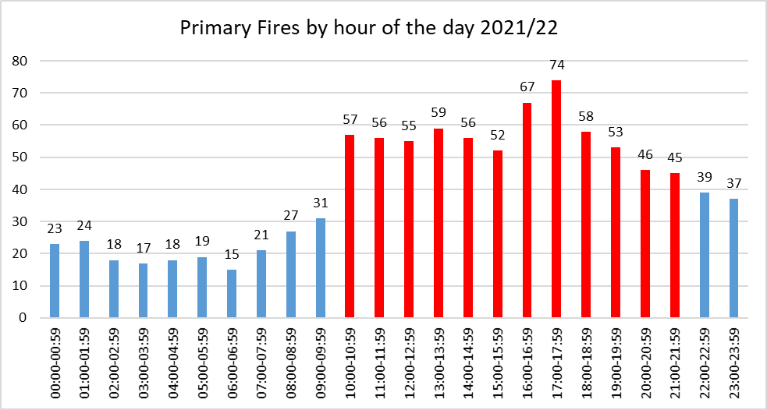Between 10:00 and 21:59 there were 678 Primary Fires (70%). The total for this 12 hour period if averaged out for the full day would be 483. Therefore, there are an extra 195 fires (20%) occurring during this peak time throughout the year. Compared to 2020/21, this peak period (45 fires per hour and above) has extended by 1 hour but with reduced numbers between 17:00 to 19:59: 185 down from 221.

5.2 Accidental Dwelling Fires

Performance April - March 2021/22: 433

Reduced ✓ by 2.5% (11) since 2020/21 from 444 to 433 fires
Reduced ✓ by 23.0% (129) since the 2009/10 baseline of 562

Main Sources and Location of Accidental Dwelling Fires

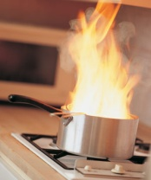
228 (53%) Accidental Dwelling Fires occurred in the kitchen, with cooking appliances the source for 177 (78%) of these kitchen ADFs.

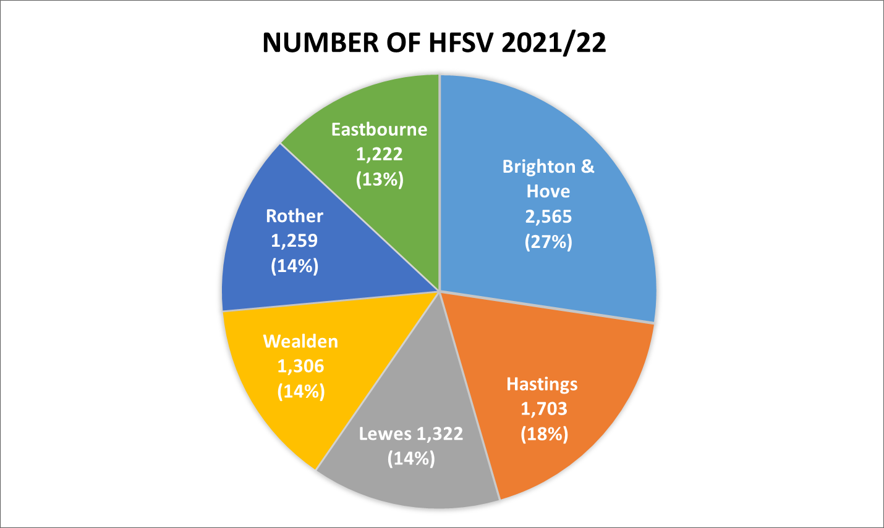
Home Fire Safety Visits

ESFRS undertook 9,377 Home Fire Safety Visits between 1st April and 31st March 2021/22. Due to the COVID-19, 2,599 of these were carried out over the telephone. Normal face to face resumed on 19 July 2021.

Accidental Dwelling Fires % Change from 2020/21 to 2021/22 by Geographical Area

7%
-28%

14%
0%

7%

-20%

Additional information for Accidental Dwelling Fires from 2020/21 to 2021/22

Brighton & Hove (B&H), Lewes and Wealden all experienced an increase in Accidental Dwelling Fires, B&H with 11 (7%), Lewes 5 (14%) and Wealden 4 (7%). Rother and Eastbourne experienced a decrease, 16 (28%) and 15 (20%) respectively.

45% of all Accidental Dwelling Fires were either in a Single occupancy (Single family unit) house or Bungalow (194). This is a decrease of 3.5% compared to 2020/21 (201). There were notable increases in Accidental Dwelling Fires in the following categories: Licenced HMO/3 or more storeys, 2 to 10 (400%); Self-contained Sheltered Housing, 18 to 25 (38.9%); and Converted Flat/Maisonette with multiple occupancy (Up to storeys), 15 to 21 (40%). Notable decreases occurred in Converted Flat/Maisonette - multiple occupancy/3 or more storeys, 66 to 48 (27.3%); House - single occupancy, 186 to 175 (5.9%); and Purpose Built Flat/Maisonette - multiple occupancy/Up to 3 storeys 88 to 78 (11.4%).

Main firefighting action by ESFRS fire crews at Accidental Dwelling Fires

49% of the Accidental Dwelling Fires attended in 2021/22 required No firefighting action by attending crews and a further 21% were dealt with by Small means, Portable extinguishers or were Allowed to burnout under the supervision of the crew. (Small means includes methods such as using a bucket of water, disconnecting a fuel supply or removing an item from a heat source for example.)

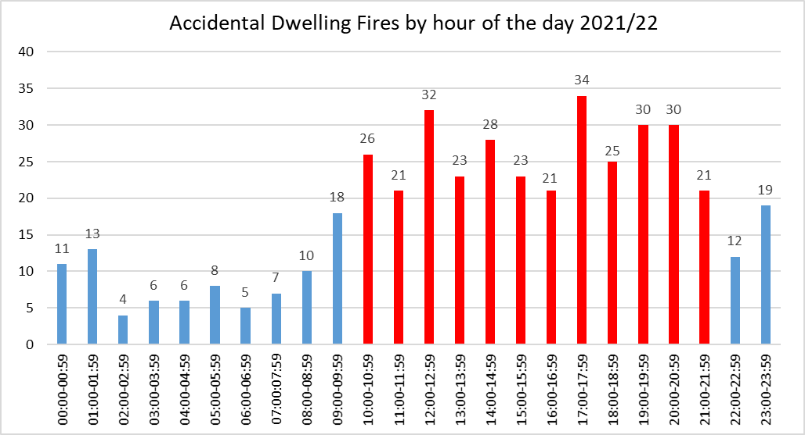
Time of Accidental Dwelling Fires

Between 10:00 and 21:59 there were 314 Accidental Dwelling Fires (73%). The total for this 12 hour period if averaged out for the full day would be 217. Therefore, there are an extra 97 fires (22%) occurring during this peak time throughout the year. Compared to 2020/21, this peak period (21 fires per hours and above) has extended by 5 hours but with reduced numbers: between 16:00 to 19:59 there was reduction from 143 to 110 ADFs.

5.3 Deliberate Fires

Performance April - March 2021/22: 664

Deliberate Primary Fires excluding Vehicle Fires
Increased by 3% (4) since 2020/21 from 145 to 149 fires
Reduced ✓ by 48% (140) since the 2009/10 baseline of 289

Deliberate Primary Fires in Vehicles
Reduced ✓ by 48% (41) since 2020/21 from 85 to 44 fires
Reduced ✓ by 81% (186) since the 2009/10 baseline of 230

Deliberate Secondary Fires
Reduced ✓ by 4% (22) since 2020/21 from 493 to 471 fires
Reduced ✓ by 45% (382) since the 2009/10 baseline of 853

Main Types of Fire

Deliberate Primary Fires – 193 fires: 29% of all Deliberate Fires

21% (40) Dwelling Fires | 23%  (44) Vehicle Fires | 11% (22) Industrial / Commercial Fires | 45% (87) Other / Outdoor Fires

Deliberate Primary Fires % change from 2020/21 to 2021/22 by Geographical Area
-5%
9%
-44%
10%
-22%
-23%

Eastbourne had the highest total and proportional decrease in Deliberate Primary Fires with 19 and 44% fires, respectively. Hastings had the highest total increase with 4, whereas Wealden had the highest proportional increase with 10%.

All information relating to trends is shared at the monthly Community Safety Performance meetings for note and action in the Groups.

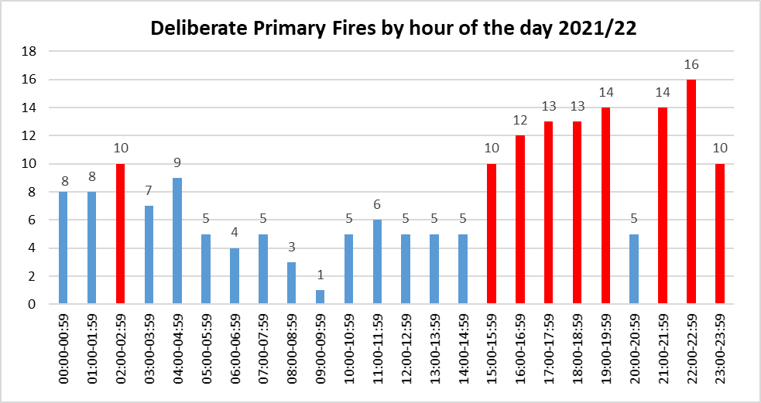
Time of Deliberate Primary Fires

Between 15:00 and 23:59 there were 107 Deliberate Primary Fires (55%). Therefore, most Deliberate Primary Fires were committed during the late afternoon and evening with another peak late night. The total for this 9 hour period if averaged out for the full day would be 72. Therefore, there are an extra 35 fires (18%) occurring during this peak time throughout the year.

Deliberate Secondary Fires – 471 fires: 71% of all Deliberate Fires

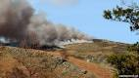  28% (131) Grassland, Woodland & Crop Fires | 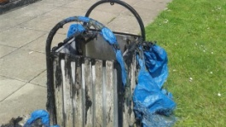  25%  (116) Refuse / Bin Fires |   47%  (224) Others

Deliberate Secondary Fires % change from 2020/21 to 2021/22 by Geographical Area
-9%
27%
-38%
19%
-11%
-22%

Hastings had the highest total and proportional increase in Deliberate Secondary Fires with 26 and 27% fires, respectively. Brighton & Hove had the highest total decrease with 37 and Rother had the highest proportional decrease with 38%.

All information relating to trends is shared at the monthly Community Safety Performance meetings for note and action in the Groups.

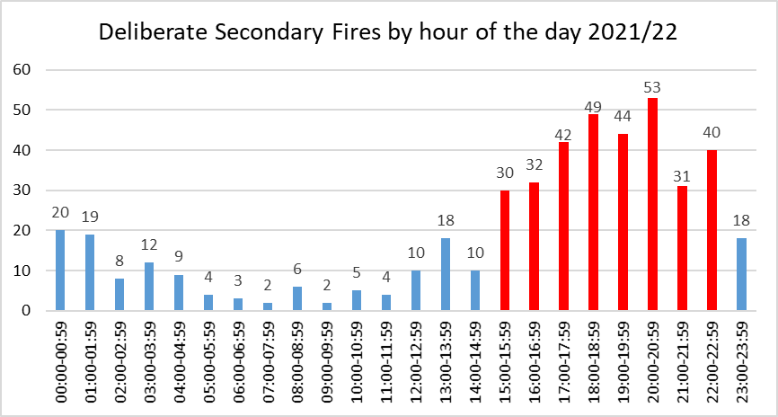
Time of Deliberate Secondary Fires

Between 15:00 and 22:59 there were 321 Deliberate Secondary Fires (68%). The total for this 8 hour period if averaged out for the full day would be 157. Therefore, there are an extra 164 fires (35%) occurring during this peak time throughout the year.
5.4 Primary Fire Fatalities & Injuries

Primary Fire Fatalities

Performance April - March 2021/22: 4
There were 4 Fire Fatalities at 3 incidents in 2021/22 which is a 100% (2) increase ✗since 2020/21.

Three of the four fatalities were female.

Age Ranges
The victims’ ages were 71, two at 72 and 82.

Three of the four fatalities were the result of Accidental Dwelling Fires.

Primary Fire Injuries

Current Performance (April - March 2021/22): 13
There were 13 injuries in 2021/22 which is a 58.1% (18) ✓decrease since 2020/21.

Main Injury Types

61.5% (8) Burns
23.1% (3) Overcome by Gas/Smoke
15.4% (2) Breathing difficulties

Age Ranges

0.0% (0) under 14
15.4% (2) between 14 and 24
7.7% (1) between 25 and 35
15.4% (2) between 36 and 45
15.4% (2) between 46 and 55
15.4% (2) between 56 and 65
7.7% (1) are 66 and over
23.1% (3) were not known

Gender

84.6% (11) were male
15.4% (2) were female

7 (53.8%) of these injuries were in Accidental Dwelling Fires.
5.5 Sickness Indicators

Performance April - March 2021/22 10.5 Shifts lost per person
All Staff Sickness is 40% above the target (7.5) ✗ (3.0 shifts) and has:
increased ✗ by 59.1% (3.9 shifts) since 2020/21 up from 6.6 shifts lost per person.

- Wholetime Staff Sickness increased ✗ by 58.8% (4 shifts) since 2020/21 from 6.8 to 10.8 shifts per person.
- Control Room Staff Sickness increased ✗ by 96.9% (6.3 shifts) since 2020/21 from 6.5 to 12.8 per person.
- Green Book (Non-Uniformed) Staff Sickness increased ✗ by 50.0% (3.1 shifts) since 2020/21 from 6.2 to 9.3 per person.

There have been 5,590.7 shifts lost in 2021/22 compared to 3,516.8 shifts lost in 2020/21.

Long Term vs Short Term Sickness

- 70.1% of sickness is classed as Long Term (more than 28 days)
- 12.0% of sickness is classed as Medium Term (8 to 27 days)
- 17.9% of sickness is classed as Short Term.

  - Health and Safety

Performance April - March 2021/22: 150 Accidents

- Decreased ✓ by 23.1% (45) since 2020/21 from 195 accidents to 150, and
- Increased ✗ by 24.0% (29) since 2010/11 from 121 accidents to 150. This is due to more detailed and accurate reporting.

For manual handling injuries, there is a decrease of 4 (13%) in 2021/22 from 31 to 27 in the number of incidents reported compared to 2020/21. This is still a 6 more incidents, a 29% increase since 2017/18.

There has been no change in the number of slips, trips and falls incidents in 2021/22 with 8 reported. These occur for a variety of reasons from operational environments, poor housekeeping and environmental conditions.

There has been a 45% increase in the number of vehicle incidents compared to 2020/21.

Lost time incidents decreased by 13% since 2020/21 from 15 to 13. This figure remains lower than the 16 in reported in 2014-15.

Incidences of work-related violence and stress remain consistently low but it is likely that these are under reported and so are not indicative of the extent of the occurrences of these types of safety events.

There has been a 49% decrease in the number of near hits reported (32 incidents) since 2020/21. This can be taken as a positive indicator of better reporting. The reporting of near hits gives the Service greater opportunity to investigate and introduce control measures before an injury results.

5.7 Level 3 & 4 Incidents attended in 2021/22
A level 3 incident is attended by between 7 and 9 appliances at one time.
A level 4 incident is attended by 10 or more appliances at one time.
During 2021/22, ESFRS attended nine level 3 incidents and no level four incidents; below are the details of top two level 3 incidents:
At 9.50am, 2nd February 2022, ESFRS were mobilised to a thatched roof fire at Hook Farm, Vine Cross, Heathfield. There were no persons reported and the property had been evacuated. Eight pumps were sent and fire crew from Uckfield, Eastbourne, Bexhill, Pevensey, Hastings Bohemia Road, Crowborough and Burgess Hill (WSFRS) attended the fire. Nearby residents were advised to keep windows and doors closed owing to the heavy smoke in the area.
Firefighters used foam, a main jet and one hose reel jet to extinguish the fire and by 3pm, the fire was under control and scaled down to two appliances. A reinspection was conducted the following day with the incident closed at 5.35pm on 3rd February 2022. In total, 16 pumps (4 of which were L4T 4 x 4 off road specialist vehicles), one aerial ladder platform and one water carrier/tanker attended the incident.
Damage to the property was extensive with the whole property flame and heat damaged. The fire investigator said the fire began in the thatched roof of the property starting from a bedroom. The probable cause was sun reflecting from a make-up mirror. However, due to the extent of the damage, it is not possible to say with absolute certainty what caused the fire.

At 3.16am, 8th July 2021, ESFRS were mobilised to reports of a fire in Woodlands Farm, Hundred Acre Lane, Wivelsfield. On arrival the first floor and the roof of a derelict farmhouse were well alight, and eight pumps were sent. The fire crew that attended the blaze were from Lewes, Barcombe, Preston Circus, Forest Row, Uckfield, Haywards Heath (WSFRS) and Burgess Hill (WSFRS).
Firefighters used main line/jet and hose reel - high pressure to tackle the fire and by 5.07am that the fire was surrounded, and de-escalation was in progress. By 6.11am the incident was scaled down to two pumps, and 6.55am to one pump. Re-inspections were conducted on the 8th and 9th July until the incident was finally closed on 9th July 2021 at 9.40pm.
In total,16 pumps and two water carriers were used during this incident. The cause of the fire was established as arson and the Police were also in attendance. The source of the ignition was lighted paper or card or other naked flame. The extent of the flame and heat damage at stop damaged the whole building but no other building was affected.

6. Compliments and Complaints received 2021/22
We received 36 complaints from members of the public in 2021/22 up from 31 recorded in 2020/21, whereas in 2021/22 we received 105 compliments up from 91 in 2020/22.
Complaints Received against the Service 2021 - 2022
No. | Nature of Complaint | Substantiated? | Action Resulting / Comments
1 | Business Safety | Logged for record purposes | Logged for record purposes for future reference
2 | Observation of Fire Appliances travelling along the seafront | Logged for record purposes | Logged for record purposes for future reference
3 | Reference to another agency | Logged for record purposes | Logged for record purposes for future reference
4 | Reference to another agency | Logged for record purposes | Logged for record purposes for future reference
5 | Insurance matter | Logged for record purposes | Logged for record purposes for future reference
6 | Service vehicle parking | Unjustified | Resolved and response issued
7 | Driving Standards | Unjustified | Resolved and response issued. Reminder issued locally re. standards expected by ESFRS
8 | Damage to property | Unjustified | Resolved and response issued
9 | Hydrant Management | Unjustified | Resolved and response issued
10 | Conduct of ESFRS employee | Unjustified | Resolved and response issued. Reminder issued locally re. standards expected by ESFRS
11 | Service vehicle parking | Justified | Resolved and response issued. Reminder issued locally re. standards expected by ESFRS
12 | Driving standards | Unjustified | Resolved and response issued. Reminder issued locally re. standards expected by ESFRS
13 | Conduct of Fire Cadet | Unjustified | Resolved and response issued. Reminder issued locally re. standards expected by ESFRS
14 | Incident response time | Justified | Resolved and response issued. Review of procedure in respect of call handling
15 | Driving standards | Logged for record purposes | Closed no further information received
16 | Service vehicle parking | Justified | Resolved and response issued. Reminder issued locally re. standards expected by ESFRS
17 | Fire Safety | Partially justified | Resolved and response issued
18 | Driving Standards | Unjustified | Resolved and response issued
19 | Service vehicle parking | Logged for record purposes | Logged for record purposes for future reference
20 | Driving Standards | Unjustified | Resolved and response issued. Reminder issued locally re. standards expected by ESFRS
21 | Fire Safety | Withdrawn | Logged for record purposes for future reference
22 | Conduct of ESFRS employee | Unjustified | Resolved and response issued
23 | Driving standards | Justified | Resolved and response issued.  Reminder issued of the standards expected by ESFRS
24 | Damage to property | Logged for record purposes | Logged for record purposes for future reference
25 | Business Safety | Partially justified | Resolved and response issued
26 | Service vehicle parking ref to 19 | Unjustified | Resolved and response issued.
27 | Use of service vehicle | Justified | Resolved and response issued. Reminder issued of the standards expected by ESFRS
28 | Driving standards | Justified | Resolved and response issued. Reminder issued of the standards expected by ESFRS
29 | Conduct of ESFRS employee | Unjustified | Resolved and response issued
30 | Damage to property | Logged for record purposes | Logged for record purposes for future reference
31 | Employee conduct | Logged for record purposes | Logged for record purposes for future reference
32 | Service vehicle parking | Partially justified | Resolved and response issued. Reminder issued of the standards expected by ESFRS
33 | Driving standards | Justified | Interagency meeting to improve understanding of ways of working
34 | Damage to property | Under Investigation | Failure to extinguish fire properly
35 | Damage to property | Logged for record purposes | Insurance matter
36 | Professional standards | Under Investigation | Confidential at this time

Appendix B - Plain English descriptions of indicators

Indicator | Plain English description | Rationale | Good Performance
Number of Primary Fires attended | The number of major fires involving property, casualties or involving 5 or more appliances | This indicator measures the incidence of fire and related casualties and is therefore a means by which individuals and communities can assess the fire safety support provided by ESFRS. | Lower numbers
Number of deaths arising from Primary Fires | The number of people whose death was caused by fire in a major fire which involves property, casualties or 5 or more appliances  The death may occur weeks or months later. |  | Lower numbers
Number of injuries (excl. Precautionary checks) arising from Primary Fires | The number of people who required medical treatment beyond first aid given at the scene of the fire per  Precautionary checks are persons sent to hospital or advised to see a doctor as a precaution, having no obvious injury or distress. |  | Lower numbers
Number of Deliberate Primary Fires (excl. Primary Fires in Vehicles) | The number of fires where the cause of fire is suspected not to be an accident, involving property, casualties or involving 5 or more fire appliances | Deliberate fires are a key component of Anti-Social Behaviour which is a national priority for Government. | Lower numbers
Number of Deliberate Primary Fires in Vehicles | The number of fires in vehicles that are not derelict where the cause of fire is suspected as not to be an accident |  | Lower numbers
Number of Deliberate Secondary Fires (excl. in Vehicles) | The number of small fires where the cause of fire is suspected not to be an accident  These include fires to: Derelict Buildings, Grass/Heath/Railway, Straw/Stubble, Refuse/Container,  Tree/Fence/Lamp. |  | Lower numbers

Indicator | Plain English description | Rationale | Good Performance
Number of Deliberate Secondary Fires in Vehicles | The number of fires where the cause of fire was not an accidental in derelict vehicles. | Deliberate fires are a key component of Anti-Social Behaviour which is a national priority for Government. | Lower numbers
Number of Home Safety Visits (HSVs) | The number of home fire safety visits where the householder was given fire safety advice and or had a fire alarm installed. | To raise awareness of the potential fire risks within the home to make them safer. | Higher numbers
Percentage of HSVs to be delivered to vulnerable people | The number of home safety visits delivered to vulnerable people within our community.  Vulnerability is defined as lone pensioners, people over 65, people in rented accommodation, single parent families, hearing /sight impaired and those with a limiting long elderly. | In Rising to the Challenge, The Audit Commission reiterates that Home Fire Safety Checks should not be conducted indiscriminately but targeted to those most at risk. | Higher percentage
Number of Accidental Dwelling Fires attended | The numbers of fires in houses where the cause was accidental | To ascertain the effectiveness of certain aspects of FRS activity including community safety education, where the public is prepared to cope with a fire event if it happens by closing doors and fitting smoke detection. And the rapid and effective response to the incident can confine the fire within the first compartment and reduce the damage and suffering. | Lower numbers
Number of Fires in Non-domestic Properties | The number of fires in buildings such as agricultural, Industrial properties, Trade, hotels, catering etc. per | To monitor the effectiveness of fire safety under the Regulatory Reform (Fire Safety) Order (RRO). | Lower number

Indicator | Plain English description | Rationale | Good Performance
Number of Inspections of High-Risk Premises to support compliance with the Fire Safety Order | The number of inspections undertaken in high-risk premises | Inspections within those premises covered by the fire safety order should reduce the perceived risk. Consequently, over time FRSs should see a positive reduction in inspection compliance outcomes within premise groups. | Higher number
Percentage of Accidental Dwelling Fires confined to room of origin | The percentage of fires that did not spread past the room they started in. | To assess response effectiveness. | Higher percentage
Number of Working Days/Shifts lost due to sickness absence for all staff | The number of days/ shifts lost to sickness divided by the number of staff in post | Sickness absence reduces the effectiveness of an organisation | Lower number
Number of Workplace Reported Accidents / Injuries | The number of accidents/ injuries reported | Staff safety is paramount, and it is important that the service measures whether health and safety procedures and initiatives to reduce physical attacks on firefighters are working. This is particularly important in light of any changes to types of station, appliances and crewing arrangements. | Lower number
Number of RIDDOR incidents | The number of injuries, deaths and dangerous occurrences reportable under the Reporting of Injuries, Diseases and Dangerous Occurrences Regulations 1995 |  | Lower number

