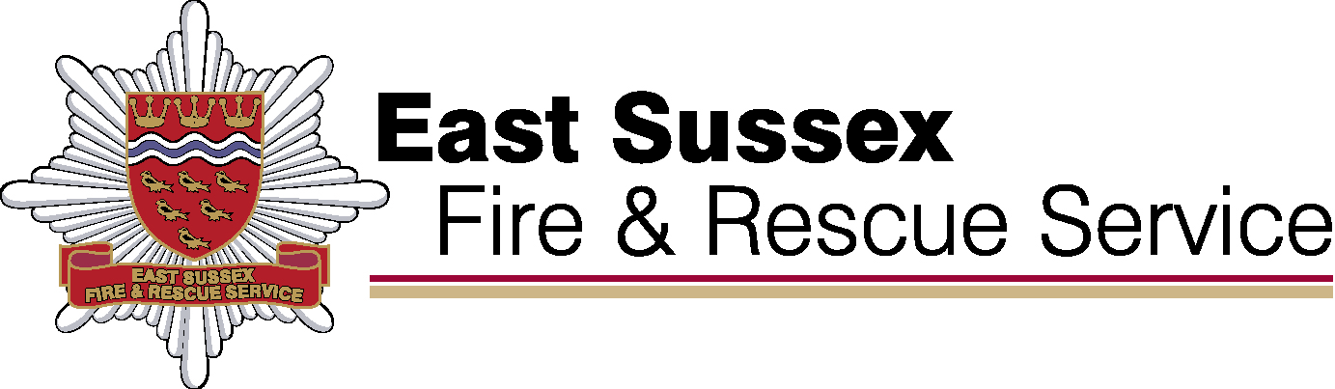

East Sussex Fire & Rescue
Performance Results
Quarter 2 2022/23

January 2023

Our Purpose

We make our communities safer

We will do this by:

Commitment 1: Delivering high performing services

We make our communities safer

We will do this by:

Commitment 2: Educating our communities

We make our communities safer

We will do this by:

Commitment 3: Developing a multi-skilled, safe and valued workforce

We make our communities safer

We will do this by:

Commitment 4: Making effective use of our resources

