APPENDIX A



Annual Performance
Outcome Report
2023/24

AUGUST 2024

Contents

Section |  | Page No.
1 | Introduction | 2
2 | Summary of Achievement | 3
3 | Performance Results 2023/24 | 4
3.1 | Commitment 1: Delivering high performing services | 4
3.2 | Commitment 2: Educating our communities | 5
3.3 | Commitment 3: Developing a multi-skilled, safe and valued workforce | 5
3.4 | Annual Priority Areas | 6-8
4 | Detailed Performance Analysis | 9
4.1 | Primary Fires | 9-11
4.2 | Accidental Dwelling Fires | 12-14
4.3 | Deliberate Fires | 15-18
4.4 | Primary Fire Fatalities and Injuries | 19
4.5 | Fire Safety Check | 20
4.6 | Sickness Indicators | 20
4.7 | Health and Safety | 20-21
4.8 | Level 3 & 4 Incidents attended in 2023/24 | 22-23
5 | Compliments and Complaints  Appendix B: Plain English descriptions of indicators | 24-26  27-29

1. Introduction

This report provides details of East Sussex Fire & Rescue Service’s (ESFRS) performance for the period April – March 2023/24.

It provides a transparent, single view of information which allows Elected Members, Auditors and members of the public to hold the Service’s senior managers and staff to account in terms of the provision and performance of their Fire & Rescue Service for 2023/24.

Our purpose is, ‘to make our communities safer’

Our purpose states what we are here for as a Fire and Rescue Service. It sets out our destination which guides our strategy development.

We have four commitments which describe what we want to achieve for our communities in order to make them safer we will:
Deliver high performing services
Educate our communities
Develop a multi-skilled, safe and valued workforce
Make effective use of our resources

Our Values describe how we expect people to behave when carrying out their work.
• We are PROUD of the service we provide
• We are ACCOUNTABLE for our actions
• We show INTEGRITY in our work
• We RESPECT our colleagues and members of the community

2. Summary of Achievement

The table below provides a key summary of our achievement against targets, or where no target is set, our achievement against the previous year’s result in our priority areas, and non-priority areas for 2023/24.

Our priority areas for 2023/24 were:
☑ Accidental dwelling fires – Target < 451
☑ To undertake 9,000 Home Safety Visits (HSVs)
☑ Deliver 90% of all HSVs to vulnerable members of our community
 Reducing the number of absences of our employees due to sickness – Target < 10
 Reducing attendance at automatic false alarms – Target < 2,820
☑ Inspections in high-risk premises – Target > 500

Indicator group | Indicators where the target has been met | Indicators that were near target | Indicators where target has not been met
Priority Areas | 4  (67%) | 1  (16.6%) | 1  (16.6%)
Non-priority areas | 9  (56%) | 4  (25%) | 3  (19%)
All Indicators | 13  (59%) | 5  (23%) | 4  (18%)

As can be seen from the above table, in 2023/24, 4 from 6 (67%) of the indicators that support the priority areas have met their targets as did 9 from 17 from the non-priority areas (56%). This is a total of 13 from 22 (59%) of all indicators meeting the target set.
☑ Achieved
 Not achieved
Near target

3. Performance Results 2023/24

Our Purpose: We make our communities safer:

3.1 Commitment 1: Delivering high performing services

Performance Measures Achieving Target
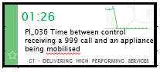
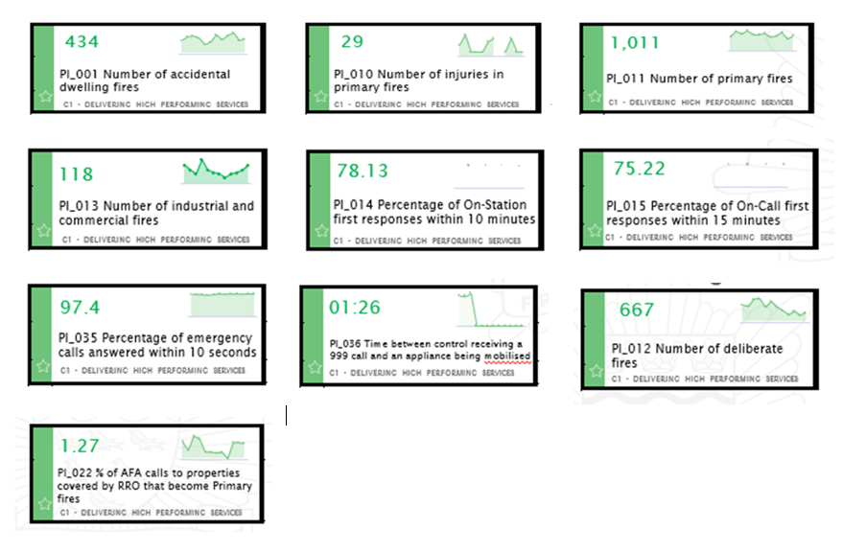
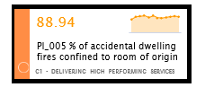
Performance Measures Near Target

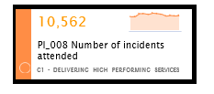

Performance Measures Needing Improvement

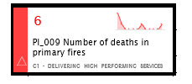
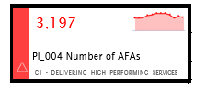

3.2 Commitment 2: Engage with our communities

Performance Measures Achieving Target
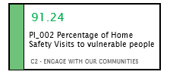
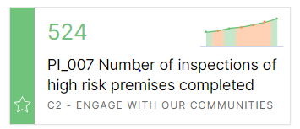
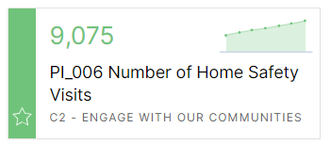

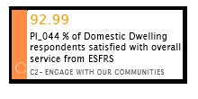
Performance Measures Near Target

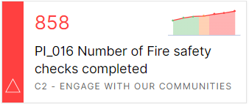
Performance Measures Needing Improvement

3.3 Commitment 3: Developing a multi-skilled, safe and valued workforce

Performance Measures Near Target
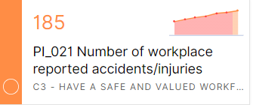
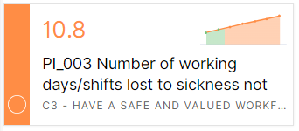

Performance Measures Needing Improvement
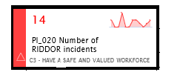

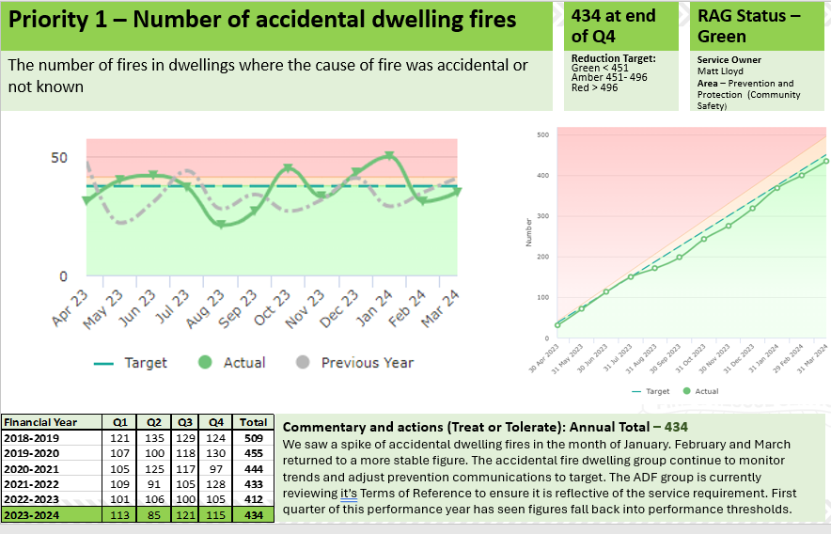
3.4 Annual Priority Areas
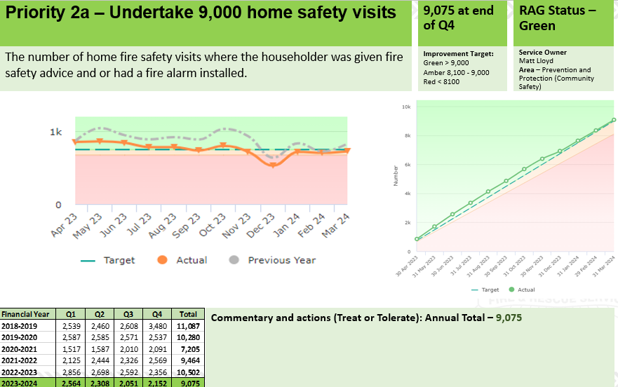

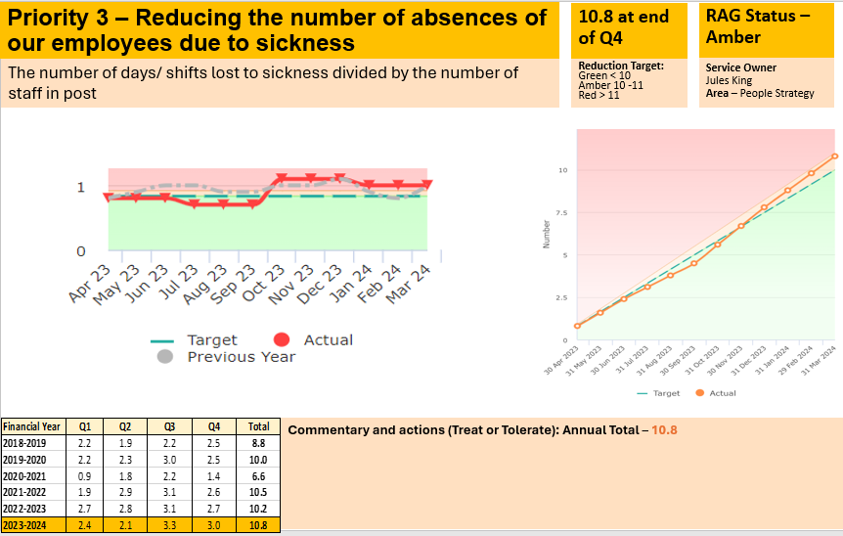
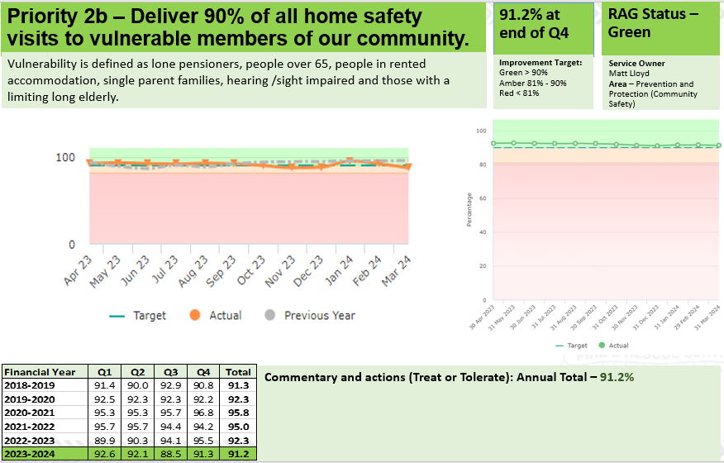
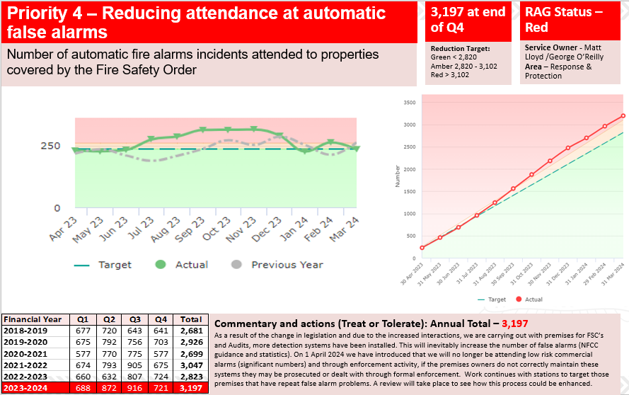

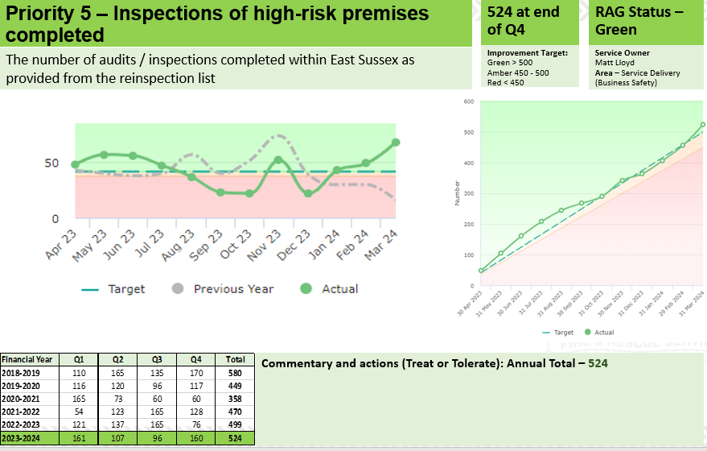

4. Detailed Performance Analysis

After analysing the overall performance information, we have identified a number of key indicators which we have undertaken additional and more detailed analysis upon.

These key indicators include:
- Primary Fires
- Accidental Dwelling Fires
- Deliberate Fires
- Primary Fire Fatalities
- Primary Fire Injuries
- Fire Safety Checks
- Sickness Indicators
- Health and Safety

This analysis has looked at the following:

- Performance against previous year
- Main Types and causes of incidents
- Geographic analysis of the location of incidents

The results of this detailed analysis are reported in the following section.

4.1 Primary Fires

Performance April-March 2023/24: 1,011 Fires

Decreased ✓ by 0.1% (1) since 2022/23 from 1,012 to 1,011 fires.
Decreased ✓ by 36.1% (570) since the 2009/10 baseline of 1,581.

Main Types of Primary Fires

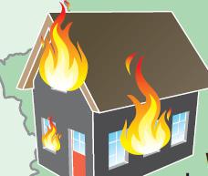47% (476) Dwelling Fires | 24%  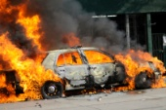  (248) Vehicle Fires | 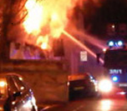12% (118) Industrial/ Commercial Fires | 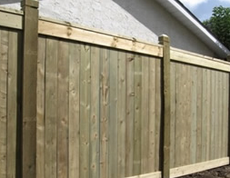17% (169) Other/  Outdoor Fires

Main Cause of Fires

23.7% (240) were Deliberate.

76.3% (771) were Accidental or Not known (main causes: Cooking with 126 incidents; Fault in equipment or appliance, 116; Overheating, unknown cause, 106; Combustible articles too close to the heat source (or fire), 99; Faulty fuel supply – electricity, 84; Careless handling - due to careless disposal, 39.

Primary Fires % change from 2022/23 to 2023/24 by Geographical Area

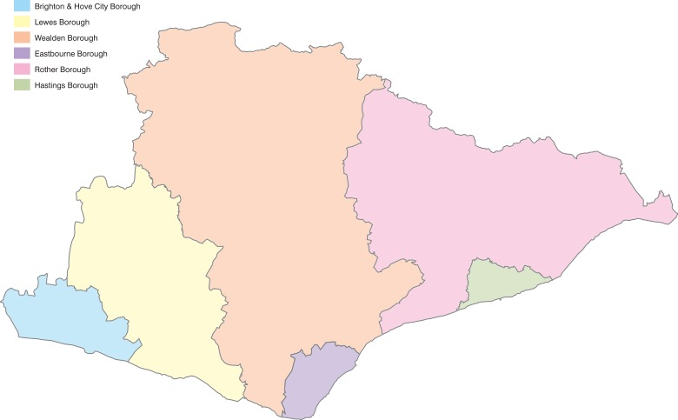

-8%
-12%

12%
-3%
1%

11%

Additional information for decreases or increases in Primary Fires from 2022/23 to 2023/24.
Lewes had the largest proportional and total increase in Primary Fires with 12% and 15 respectively.
Rother had the largest total decrease of Primary Fires with 15 and the largest proportional decrease with 12%.
A breakdown of the total Primary Fires in Brighton & Hove, which had the greatest number with 309, was as follows: 169 (55%) were in Dwellings; 55 (18%) in Vehicles; 44 (14%) were Other/Outdoor Fires: and 41 (13%) were in Non-domestic Premises. Since 2022/23, Primary Fires have increased by 28 in Dwellings, but decreased by 16 in vehicles; 5 in Other/outdoor properties and 3 in Non-domestic Premises.

Main firefighting action by ESFRS fire crews at Primary Fires

32.5% of the Primary Fires attended in 2023/24 required ‘No firefighting’ by the attending crews and a further 18.6% were dealt with by ‘small means’, ‘Portable extinguishers’ or were ‘Allowed to burnout’ under the supervision of the crew. (Small means includes methods such as using a bucket of water, disconnecting a fuel supply or removing an item from a heat source for example.)

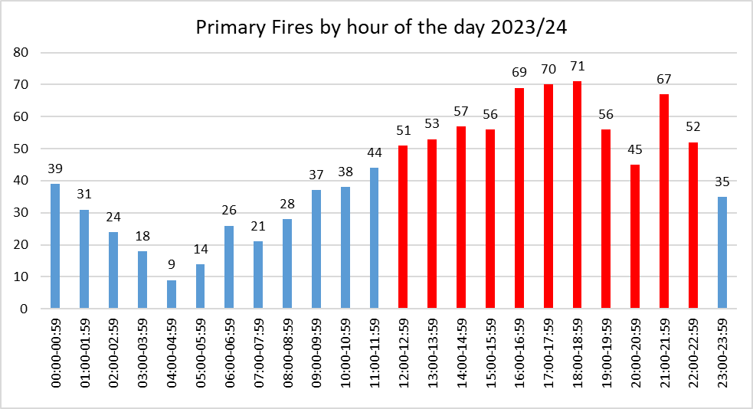
Time of Fires

Between 12:00 and 22:59 there were 647 Primary Fires (64%). The total for this 11-hour period if averaged out for the full day would be 463. Therefore, there are an extra 184 fires occurring during this peak time throughout the year. Compared to 2022/23, this peak period has shifted forward by 1 hour.

4.2 Accidental Dwelling Fires

Performance April - March 2023/24: 434

Increased ✗ by 5.3% (22) since 2022/23 from 412 to 434 fires.
Reduced ✓ by 22.8% (128) since the 2009/10 baseline of 562

Main Sources and Location of Accidental Dwelling Fires

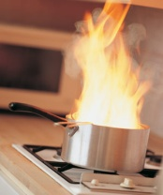
255 (59%) Accidental Dwelling Fires occurred in the kitchen, with cooking appliances the source for 187 (73%) of these kitchen ADFs.

Accidental Dwelling Fires % Change from 2022/23 to 2023/24 by Geographical Area

-13%
-14%

32%
-7%

15%

14%

Additional information for Accidental Dwelling Fires from 2022/23 to 2023/24

Brighton & Hove (B&H) with 20 (15%); Lewes, 13 (32%) and Eastbourne, 8 (14%) experienced an increase in Accidental Dwelling Fires. Wealden, 8 (13%); Rother, 6 (14%) and Hastings, 5 (7%) all experienced an increase.

47% of all Accidental Dwelling Fires were either in a Single occupancy (Single family unit) house or Bungalow (205). This is the same percentage as in 2022/23 but an increase in number of incidents (11). There were increases in Accidental Dwelling Fires in the following categories: Converted Flat/Maisonette - multiple occupancy/3 or more storeys, 40 to 53 (33%); Unknown if licensed HMO/Up to 2 storeys, 1 to 3 (200%); Licensed HMO/3 or more storeys, 5 to 7 (40%); Self-contained Sheltered Housing, 21 to 22 (5%) and Purpose Built Flat/Maisonette - multiple occupancy/4 to 9 storeys, 46 to 48 (4%). There were notable decreases in Purpose Built Flat/Maisonette - multiple occupancy/10 or more storeys, 8 to 3 (63%) and Licensed HMO/Up to 2 storeys, 6 to 5 (17%).

Main firefighting action by ESFRS fire crews at Accidental Dwelling Fires

46% of the Accidental Dwelling Fires attended in 2023/24 required ‘No firefighting’ action by attending crews and a further 24% were dealt with by ‘small means’, ‘Portable extinguishers’ or were ‘Allowed to burnout’ under the supervision of the crew. (Small means includes methods such as using a bucket of water, disconnecting a fuel supply or removing an item from a heat source for example.)

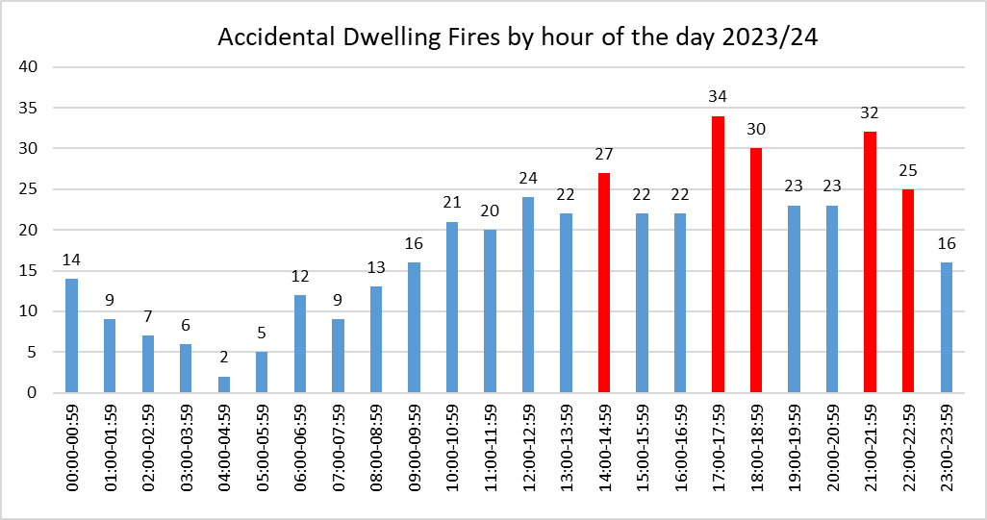
Time of Accidental Dwelling Fires

Between 14:00 and 22:59 there were 238 Accidental Dwelling Fires (55%). The total for this 10-hour period if averaged out for the full day would be 181. Therefore, there are an extra 57 fires occurring during this peak time throughout the year. In 2022/23, during this peak period, there were 230 fires. Significantly, there were more than double the fires between 00.00 and 02.49 in 2023/24 with 30 compared to 13 in the previous year.

4.3 Deliberate Fires

Performance April - March 2023/24: 668

Deliberate Primary Fires excluding Vehicle Fires
Increased by 1.3% (2) since 2022/23 from 155 to 157 fires.
Reduced ✓ by 45.7% (132) since the 2009/10 baseline of 289.

Deliberate Primary Fires in Vehicles
Increased by 15.3% (11) since 2022/23 from 72 to 83 fires.
Reduced ✓ by 63.9% (147) since the 2009/10 baseline of 230.

Deliberate Secondary Fires
Reduced ✓ by 13.9% (69) since 2022/23 from 497 to 428 fires.
Reduced ✓ by 49.8% (425) since the 2009/10 baseline of 85

Main Types of Fire

Deliberate Primary Fires – 240 fires: 36% of all Deliberate Fires

18% (42) Dwelling Fires | 34%  (83) Vehicle Fires | 12% (28) Industrial / Commercial Fires | 36% (87) Other / Outdoor Fires

Deliberate Primary Fires % change from 2022/23 to 2023/24 by Geographical Area
52%
0%
2%
30%
-3%
-12%

Eastbourne had the highest total and proportional increase in Deliberate Primary Fires with 11 and 52% fires, respectively. Brighton and Hove had the highest total decrease with 7 and 12%, respectively.

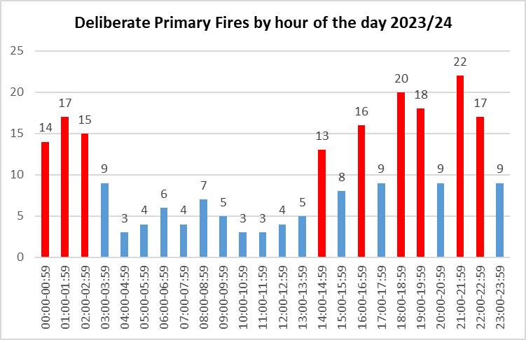
Time of Deliberate Primary Fires

Between 16:00 and 22:59 there were 111 Deliberate Primary Fires (46%). Therefore, a high proportion of Deliberate Primary Fires were committed during the late afternoon and evening with another peak in the early morning. The total for this 7-hour period if averaged out for the full day would be 70. Therefore, there are an extra 41 fires occurring during this peak time throughout the year.

Deliberate Secondary Fires – 428 fires: 64% of all Deliberate Fires

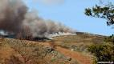  31% (132) Grassland, Woodland & Crop Fires | 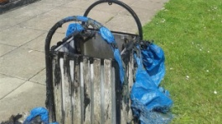  27%  (114) Refuse / Bin Fires |   42%  (182) Others

Deliberate Secondary Fires % change from 2022/23 to 2023/24 by Geographical Area
-32%
19%
-16%
-22%
9%
-18%

Rother had the highest total and proportional increase in Deliberate Secondary Fires with 9 and 19% fires, respectively. Eastbourne had the highest total and proportional decrease with 29 and 32% respectively.

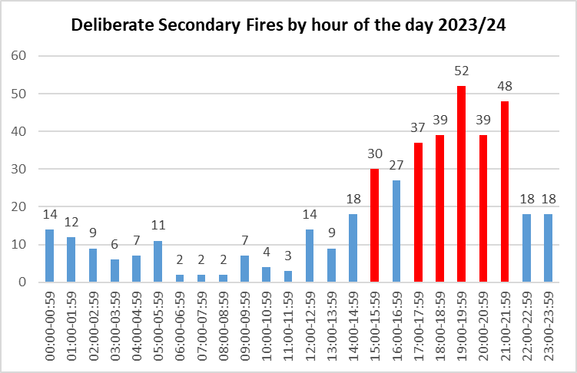
Time of Deliberate Secondary Fires

Between 17:00 and 21:59 there were 215 Deliberate Secondary Fires (50%). The total for this 5-hour period if averaged out for the full day would be 89. Therefore, there are an extra 126 fires occurring during this evening peak time throughout the year.
4.4 Primary Fire Fatalities & Injuries

Primary Fire Fatalities

Performance April - March 2023/24: 6
There were 6 Fire Fatalities at 6 incidents in 2023/24 which is a 200% (4) increase since 2022/23.

Three were female and three were male.

Age Ranges
The victims’ ages were between 42 and 94, However, no age was given in three cases.

Three of the six fatalities were the result of Accidental Dwelling Fires.

Primary Fire Injuries

Current Performance (April - March 2023/24): 29
There were 29 injuries in 2023/24, which is a 7.4% (2) increase since 2022/23.

Main Injury Types

33.3% (10) Overcome by Gas/Smoke
33.3% (10) Burns
20.0% (6) Breathing difficulties
10.0% (3) Other (Smoke inhalation)
3.3% (1) Fracture

(NB. One injury was a combination of burns and overcome by gas/smoke, therefore the total injury number is 30)

Age Ranges

13.8% (4) under 14
3.4% (1) between 14 and 24
17.2% (5) between 25 and 35
10.3% (3) between 36 and 45
10.3% (3) between 46 and 55
20.7% (6) between 56 and 65
17.2% (5) are 66 and over
6.9% (2) were not known

Gender

62.1% (18) were male
37.9% (11) were female

19 (65.5%) of these injuries were in Accidental Dwelling Fires.

4.5 Fire Safety Checks

Performance April - March 2023/24: 886

Fire Safety Checks undertaken by Operational Crew Members or Business Safety Officers
Decreased by 41.8% (637) since 2022/23 from 1,523 to 886 fire safety checks.
Increased ✓ by 61.8% (548) since the 2019/20 baseline of 338. 2019/20 was the first full year that these types of Fire safety Checks were undertaken.

4.6 Sickness Indicators

Performance April - March 2023/24 10.8 Shifts lost per person
All Staff Sickness is 7.4% above the target (10) ✗ (0.8 shifts) and has:
increased ✗ by 5.5% (0.6 shifts) since 2022/23 up from 10.2 shifts lost per person.
- Wholetime and LCS Staff Sickness increased ✗ by 12.6% (1.5 shifts) since 2022/23 from 10.4 to 11.9 shifts per person.
- Green Book (Non-Uniformed) Staff Sickness decreased ✓ by 3.5% (0.3 shifts) since 2022/23 from 8.8 to 8.5 per person.

There have been 5,889.8 shifts lost in 2023/24 compared to 5,775.6 shifts lost in 2022/23.

Long Term vs Short Term Sickness

- 56.4% of sickness is classed as Long Term (more than 28 days)
- 21.3% of sickness is classed as Medium Term (8 to 27 days)
- 22.3% of sickness is classed as Short Term.

4.7 Health and Safety

Performance April - March 2023/24: 184 Accidents

- Decreased ✓ by 5.2% (10) since 2022/23 from 194 accidents to 184, and
- Increased ✗ by 52.1% (63) since 2010/11 from 121 accidents to 184. This is due to more detailed and accurate reporting.

There has been an increase from 8 to 14 (75%) in the number of RIDDOR incidents in 2023/24. For manual handling reported injuries, there has been no change with 34 incidents compared to 2022/34. This is 13 more incidents, a 62% increase since 2017/18.

There has been an increase in the number of slips, trips and falls incidents in 2023/24 with 7 reported, up from 4 (75%). These occur for a variety of reasons from operational environments, poor housekeeping and environmental conditions.

There has been a 7.5% decrease in the number of vehicle incidents compared to 2022/23 down from 53 to 49.

Lost time incidents increased by 8% since 2022/23, up from 25 to 27.

Incidences of work-related violence is up from 8 to 12 since 2022/23 but stress down from 14 to 10. This is likely owing to increase reporting but may still not be indicative of the extent of the occurrences of these types of safety events.

There has been a 13.3% increase in the number of near hits reported (4 incidents: 30 up to 34) since 2022/23. The reporting of near hits gives the Service greater opportunity to investigate and introduce control measures before an injury results.
4.8 Level 3 & 4 Incidents attended in 2023/24
A level 3 incident is attended by between 7 and 9 appliances at one time.
A level 4 incident is attended by 10 or more appliances at one time.
During 2023/24, ESFRS attended 9 level 3 incidents and 4 level four incidents; below are the details of the level 4 incidents:
- At 17.23, 15th July 2023, ESFRS was mobilised to a fire that occurred on the fourth floor of the Royal Albion Hotel, a Grade II listed building, on the Brighton Sea Front. The fire spread quickly hastened by strong winds from the shore fanning the fire and it was not long before it spread across several floors and up into the roof. As smoke spread across the City Centre the Police closed off the Old Steine and part of the A259 King’s Road to traffic due to health and safety concerns, with fears that the building could collapse.
Everyone in the building was evacuated safely. Fifteen fire engines went to the scene just before 5.30pm on Saturday. At 5am on Sunday, the fire service said it was “scaling back operations” but six vehicles and two aerial ladder platforms (ALPs) remained on the scene. In total 112 pumps were used, including support from Kent, Surrey, West Sussex and London FRSs. There was a total of 71 hours from the first pump’s arrival to the last pump leaving.
The fire at the Albion Hotel in Brighton was accidental, with a fire investigation concluding that it was likely started by a discarded cigarette which had not been completely put out. As all the people were evacuated there were no injuries caused by this fire. However, the extensive damage to this historic building led to the demolition of almost all the Hotel except the East Section.

- At 6.32am, 12th April 2023, ESFRS was called out to a fire at Staverton Nursery, a garden centre at Halland near Uckfield. Smoke was reported issuing from a barn known to be storing chemicals for retail use and this was quickly established as a major incident with 12 pumps sent to scene. Motorists on the A22 were advised to avoid the area. Importantly, no persons were reported but initial crew’s understanding the size and scale of the incident early allowed extra resources to arrive in a timely manner to contain the fire and prevent it spreading into other areas. Although under control, the fire took around 10 and half hours to put out, which was followed by a couple of re-inspections.
Owners of Staverton Nursery stated after the incident that the following days had been difficult, as the fire had caused significant damage to the retail area and cafe. In their statement about the future of the business, the owners also expressed their gratitude to the ESFRS, who they say were there in their "hour of need". The cause of fire is still unknown but the source of ignition was considered to be electricity supply.

- At 6.20pm, 3rd October 2023, the ESFRS was called to a fire at Flat 11, Richard Allen Court, Saunders Park View Brighton. The informant saying that this was caused by an e-bike. The fire quickly took hold with two rooms alight and 6 pumps were initially sent to the incident. A person was also reported climbing from a window and an ambulance was sent. On attendance this incident was initially upgraded to a Make Pump 8 then by 6.47pm to a Make Pump 10 incident. This was a building comprising of 12 flats and all other tenants were quickly evacuated. The fire was extinguished by 19.15 with the fire contained to the two rooms. One person was reported injured in this incident which occurred whilst escaping. They suffered a fracture and required hospital treatment. Two reinspections were carried out, one at 1.42am the other at 7.34am, with the incident finally closed at 8.12am on 4th October. It was confirmed that the cause of the fire was an e-bike battery on charge.

- At 4.17pm, 1st July 2023, ESFRS was called to a fire reported at Havelock Place Hastings. This is a commercial building, 7-storey high rise office block, used by the DWP. Early intervention by crews prevented the fire from escalating. At the height of the incident 11 pumping appliances and an ALP were in attendance (two pumps from Kent FRS). All appliances left the scene by approximately 20:00hrs. No injuries were reported
A Tier 2 Fire Investigation was carried out stating that the probable cause of fire was deliberate ignition by two youths using aerosol can and lighters to set fire to flammable insulation stored and installed under ground floor and in lower ground floor areas.

5. Compliments and Complaints received 2023/24

We received 115 compliments and 43 complaints from members of the public this year.
We received 23 more compliments in 2022/23 and a total of 36 complaints in 2022/23.

Compliments Received 2023 - 2024
Incidents | CFS (HSVs, Education, Firebike, Fire cadets | Volunteers | Other (Switchboard, Bus Safety, Control etc) | Commercial Training
28 | 74 | 8 | 3 | 2

Complaints Received 2023 - 2024
No. | Nature of Complaint | Substantiated? | Action Resulting / Comments
1 | Non attendance to incident | Justified | Review of Service process
2 | Protection | Logged for record purposes | N/A
3 | Protection | Logged for record purposes | N/A
4 | Social media | Logged for record purposes | N/A
5 | Driving Blues | Unjustified | N/A
6 | Verbal abuse | Logged for record purposes | N/A
7 | Driving Blues | Justified | Line Manager to remind of driving standards
8 | Smoke from incident | Unjustified | N/A
9 | Medical Actions | Unjustified | Passed to Training
10 | HSV Info only | Logged for record purposes | N/A
11 | Protection | Logged for record purposes | N/A
12 | Missing Items | Logged for record purposes | N/A
13 | Protection | Logged for record purposes | N/A
14 | Passed to WSFRS | Logged for record purposes | N/A
15 | Incident Actions | Unjustified | N/A
16 | Actions on attending a False alarm | Unjustified | Core Brief Item to remind staff
17 | Fire Marshalls | Logged for record purposes | N/A
18 | Protection | Logged for record purposes | N/A
19 | Protection | Logged for record purposes | N/A
20 | Personal Data Disclosure | Justified | Data Protection Officer to remind of process
21 | Unlawful Parking | Justified | Line Manager to remind of expectations
22 | Flooding Call | Unjustified | N/A
23 | Protection | Logged for record purposes | N/A
24 | Flagpole | Unjustified | N/A
25 | FB Comms | Logged for record purposes | N/A
26 | Protection | Logged for record purposes | N/A
27 | Bullying | Logged for record purposes | N/A
28 | Fire Service Actions | Partially Upheld | Sent to Op P & P for reminder of policy
29 | Protection | Logged for record purposes | N/A
30 | Protection | Logged for record purposes | N/A
31 | JFC Information | Logged for record purposes | N/A
32 | Incident Attendance | Logged for record purposes | N/A
33 | Auction Appliance | Justified | Review of Service process
34 | Incorrect Service | Logged for record purposes | N/A
35 | Inconsiderate parking | Partially Upheld | Line Manager to remind of expectations
36 | Service Actions at incident | justified | Line Manager to remind of expectations
37 | Protection | Logged for record purposes | N/A
38 | Damage to Vehicle | Unjustified | N/A
39 | Damage to Property | Unjustified | N/A
40 | Incident Response | Unjustified | N/A
41 | Protection | Logged for record purposes | N/A
42 | Protection | Logged for record purposes | N/A
43 | Estates | Investigation Ongoing | N/A

Appendix B

Plain English descriptions of indicators

Indicator | Plain English description | Rationale | Good Performance
Number of Primary Fires attended | The number of major fires involving property, casualties or involving 5 or more appliances | This indicator measures the incidence of fire and related casualties and is therefore a means by which individuals and communities can assess the fire safety support provided by ESFRS. | Lower numbers
Number of deaths arising from Primary Fires | The number of people whose death was caused by fire in a major fire which involves property, casualties or 5 or more appliances  The death may occur weeks or months later. |  | Lower numbers
Number of injuries (excl. Precautionary checks) arising from Primary Fires | The number of people who required medical treatment beyond first aid given at the scene of the fire per  Precautionary checks are persons sent to hospital or advised to see a doctor as a precaution, having no obvious injury or distress. |  | Lower numbers
Number of Deliberate Primary Fires (excl. Primary Fires in Vehicles) | The number of fires where the cause of fire is suspected not to be an accident, involving property, casualties or involving 5 or more fire appliances | Deliberate fires are a key component of Anti-Social Behaviour which is a national priority for Government. | Lower numbers
Number of Deliberate Primary Fires in Vehicles | The number of fires in vehicles that are not derelict where the cause of fire is suspected as not to be an accident |  | Lower numbers
Number of Deliberate Secondary Fires (excl. in Vehicles) | The number of small fires where the cause of fire is suspected not to be an accident  These include fires to: Derelict Buildings, Grass/Heath/Railway, Straw/Stubble, Refuse/Container,  Tree/Fence/Lamp. |  | Lower numbers

Indicator | Plain English description | Rationale | Good Performance
Number of Deliberate Secondary Fires in Vehicles | The number of fires where the cause of fire was not an accidental in derelict vehicles. | Deliberate fires are a key component of Anti-Social Behaviour which is a national priority for Government. | Lower numbers
Number of Home Safety Visits (HSVs) | The number of home fire safety visits where the householder was given fire safety advice and or had a fire alarm installed. | To raise awareness of the potential fire risks within the home to make them safer. | Higher numbers
Percentage of HSVs to be delivered to vulnerable people | The number of home safety visits delivered to vulnerable people within our community.  Vulnerability is defined as lone pensioners, people over 65, people in rented accommodation, single parent families, hearing /sight impaired and those with a limiting long elderly. | In Rising to the Challenge, The Audit Commission reiterates that Home Fire Safety Checks should not be conducted indiscriminately but targeted to those most at risk. | Higher percentage
Number of Accidental Dwelling Fires attended | The numbers of fires in houses where the cause was accidental | To ascertain the effectiveness of certain aspects of FRS activity including community safety education, where the public is prepared to cope with a fire event if it happens by closing doors and fitting smoke detection. And the rapid and effective response to the incident can confine the fire within the first compartment and reduce the damage and suffering. | Lower numbers
Number of Fires in Non-domestic Properties | The number of fires in buildings such as agricultural, Industrial properties, Trade, hotels, catering etc. | To monitor the effectiveness of fire safety under the Regulatory Reform (Fire Safety) Order (RRO). | Lower number

Indicator | Plain English description | Rationale | Good Performance
Number of Inspections of High-Risk Premises to support compliance with the Fire Safety Order | The number of inspections undertaken in high-risk premises | Inspections within those premises covered by the fire safety order should reduce the perceived risk. Consequently, over time FRSs should see a positive reduction in inspection compliance outcomes within premise groups. | Higher number
Percentage of Accidental Dwelling Fires confined to room of origin | The percentage of fires that did not spread past the room they started in. | To assess response effectiveness. | Higher percentage
Number of Working Days/Shifts lost due to sickness absence for all staff | The number of days/ shifts lost to sickness divided by the number of staff in post | Sickness absence reduces the effectiveness of an organisation | Lower number
Number of Workplace Reported Accidents / Injuries | The number of accidents/ injuries reported | Staff safety is paramount, and it is important that the service measures whether health and safety procedures and initiatives to reduce physical attacks on firefighters are working. This is particularly important in light of any changes to types of station, appliances and crewing arrangements. | Lower number
Number of RIDDOR incidents | The number of injuries, deaths and dangerous occurrences reportable under the Reporting of Injuries, Diseases and Dangerous Occurrences Regulations 1995 |  | Lower number

